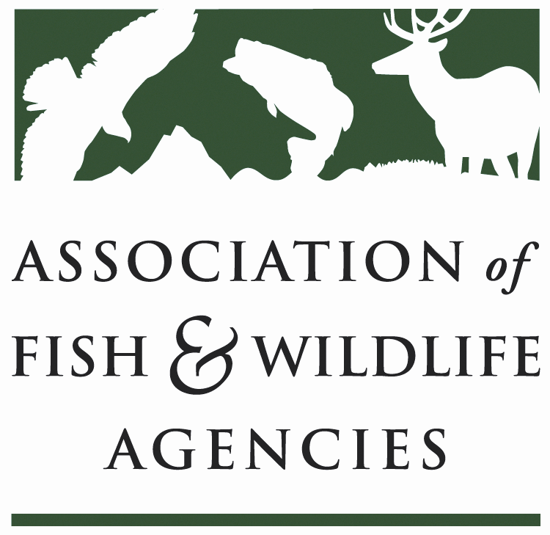

Wildlife diversity conservation & funding Committee
Chair: Sara Parker Pauley (Missouri Dept. of Conservation)
Vice Chair: David Whitehurst (Virginia Dept. Game & Inland Fisheries)

Thursday March 29, 2018
8:00 am to 12:00 pm

North American Wildlife and Natural Resources Conference
Salon F
Hilton-The Main | Norfolk, VA

Committee Charge Advocate for long-term dedicated funding and annual appropriations for the conservation of Species of Greatest Conservation Need, nature-based recreation and conservation education; support development, implementation and revision of State Wildlife Action Plans.

Agenda
08:00AM Call to Order/Review Agenda/Introductions-Sara Parker Pauley, MDOC

08:15AM Approval of Committee Report from the September 2017 Meeting-Sara Parker Pauley, MDOC

08:30AM Recovering America’s Wildlife Act/Alliance for America’s Fish & Wildlife
- House & Senate Legislation-Jen Mock Schaeffer, AFWA and Collin O’Mara, NWF
- Campaign-Sean Saville, AFWA
- Advocacy by NWF Affiliates-Naomi Edelson, NWF
- Report from EOD/WDCF Joint Working Group-Jen Newmark, NDOW

09:15AM Blue Ribbon Panel Agency Relevancy Working Group-Steve Williams, WMI

09:45AM Conservation without Conflict-Wendy Weber, USFWS

10:00AM -BREAK-

10:15AM State & Tribal Wildlife Grants-Mark Humpert
- FY18 & FY19 Budgets
- House & Senate Dear Colleague Letters
- 2018 Fly-in
- Competitive State Wildlife Grants Working Group
- State Wildlife Grants Effectiveness Measures Framework

10:45AM Wildlife & Sport Fish Restoration Program Report-Steve Klein, USFWS
11:00AM State Wildlife Action Plans-Mark Humpert
- Implementation Best Practices Working Group
- Federal/State MOU

11:15AM Review & Revision of Land and Water Conservation Fund Principles-Jen Mock Schaeffer, AFWA and David Whitehurst, VDGIF

11:45AM Review 2018 Committee Work Plan

12:00PM Adjourn

