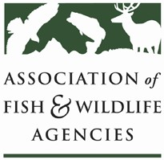

CLIMATE CHANGE COMMITTEE
Chair: Vacant

Friday, March 30, 2018
10:00 AM – 12:00 Noon

83rd North American Wildlife and Natural Resources Conference
Norfolk, Virginia

Committee Charge

- Build capacity within and among state fish and wildlife agencies to begin integrating climate change in to the normal business of the conservation of fish and wildlife.
- Serve as a forum for networking, information sharing, and lessons learned on climate change issues.
- Serve as the coordinated voice of the fish and wildlife agencies on climate change issues with conservation partners, other sectors, legislators, and appropriators.
- Serve as a conduit for sharing emerging research on climate change and climate adaptation and develop recommended approaches for state agencies to incorporate climate change considerations into fish and wildlife conservation

Agenda

- Call to Order/Review Agenda
- Introductions & Member Roundtable
One representative per member agency highlights one initiative or issue

- Climate Adaptation Leadership Award Update
(AFWA, partners)

- AFWA Adaptation Program Manager Hiring Update
(AFWA)

- Program Updates
  - State Fish and Wildlife Agencies
  - Federal Agencies
  - Other Members and Partners

- Committee Discussion: Status of Federal Climate Change and Climate Science Programs - What is AFWA’s Role?
(All)

