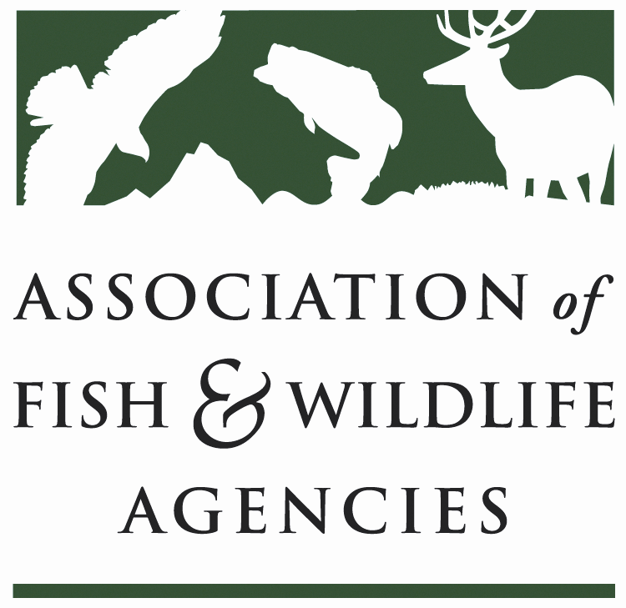
Science & Research Committee
Chair: Russ Mason (MI)
Vice-Chair: Karen Waldrop (KY)

Wednesday, March 28, 2018
1:00 – 3:00 PM
83rd North American Wildlife and Natural Resources Conference
Norfolk, Virginia

Agenda

- Call to Order/Review Agenda/Introductions (5 minutes)
Russ Mason (MI)

- Committee Business (55 minutes)
  - Monarch Butterfly Conservation Efforts Ed Boggess and Claire Beck (MAFWA)
  - National Cooperators Coalition update John Kennedy (WY)
  - Strategic, Collaborative Science to Inform Conservation at USFWS Benjamin Tuggle (USFWS) and John Organ (USGS)
  - USFS Strategic Science Plan Monica Tomosy (USFS)
  - Landscape Conservation Update Elsa Haubold (USFWS)
  - Fish and Wildlife Science in the Federal Budget Jen Mock Schaeffer and Jonathan Mawdsley (AFWA)

- Committee Discussion: Human Dimensions and Social Science at AFWA (60 minutes)
  - Introduction and Case Studies Ann Forstchen (FL), convener and discussion leader

Objectives and Desired Outcomes for Committee Discussion:
  - Identification of significant contributions of human dimensions and social science to state and federal fish and wildlife management
  - Identification of significant outstanding questions in state and federal fish and wildlife management that could be addressed with human dimensions and social science
  - Discussion and possible action on the creation of a subcommittee or working group at AFWA dedicated to human dimensions and social science

- Adjourn

