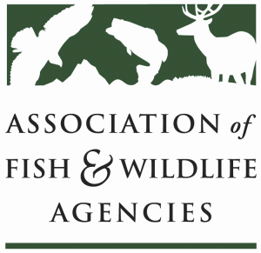

Invasive species Committee
Chair: Bill Hyatt (CT)
Vice-Chair: Kim Bogenschutz (IA)

Wednesday, March 28, 2018
TIME: 1:00 pm to 5 pm (ET)

North American Wildlife and Natural Resources Conference
Room: TBD/Hilton The Main Hotel
Norfolk, VA

Agenda
1:00 pm Call to Order, Welcome and Introductions, Review Agenda
Bill Hyatt, CT DEEP

1:15 AFWA updates
Recovering America’s Wildlife Act and Invasive Species
Priya Nanjappa, AFWA
New Committee working groups, next steps
Interstate movement of invasive species, short and long term options
Increasing communication and coordination with state departments of agriculture
Updating the MOU between PIJAC, USFWS and AFWA
Bill Hyatt, CT DEEP

1:30 DOI Initiatives and Invasive Species
Scott Cameron, Acting Assistant Secretary Policy, Management and Budget

2:15 Partner updates
USFWS (TBD/David Hoskins/Dave Miko)
ANS Task Force (Kim Bogenschutz, IA DNR)
Wildlife Forever (Pat Conzemius)

3:00 BREAK

3:15 Feral Cat Working Group Update
Colin Gillin, ODFW

3:30 NISC and ISAC Initiatives and Updates
Jamie Reaser, National Invasive Species Council

Agenda, cont’d

3:50 Biodiversity Information Serving Our Nation (BISON) database & invasive species
Gerald “Stinger” Guala, USGS

4:10 Relevant Legislative Updates
Devin DeMario, AFWA

4:30 Round Robin (all)

4:50 Summary of Action Items and Wrap-Up

5:00 Adjourn

