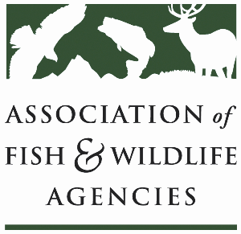

**Sustainable Use of Wildlife Committee**

[**90th North American Wildlife and Natural Resources Conference**](https://wildlifemanagement.institute/conference)

**Galt House Hotel**

**Louisville, Kentucky**

**Chair: vacant**

**Vice-Chair: Dave Kay (Alberta)**

Wednesday, March 12th, 2025

1:15 PM – 3:15 PM (CDT)

**Committee Charge:**

Advocate the North American Model of Fish and Wildlife Conservation and promote the sustainable use of fish and wildlife resources at the international level.

**Subcommittees and Working Groups:**

U.S. Furbearer Conservation Technical Working Group

**Agenda**

* Agenda review, adjustments, and opening comments ()
* Introductions ()
* Approval of [Minutes](https://www.fishwildlife.org/application/files/4617/3775/8477/Sustainable_Use_Committee_Minutes_AFWA_2024_draft.pdf) from the previous meeting ()
* Office of Conservation Investment; update on National Survey of Fishing, Hunting, and Wildlife Associated Recreation Addendum Reports (Tom Decker, USFWS)
* Update on CITES (Deb Hahn, AFWA)
* Update from Conservation Visions (Shane Mahoney)
* Safari Club International (Chris Tymeson, Regina Lennox, Bee Frederick)
* The Louisiana Black Bear Story (Regina Lennox, Maria Davidson)
* The sustainable use of black bear fur in international trade (Bryant)
* Update: Current and Future Multistate Grants/Best Management Practices for Trapping Program (Bryant)
* Update: Canadian Trap Testing and Certification Program (Dave Kay)