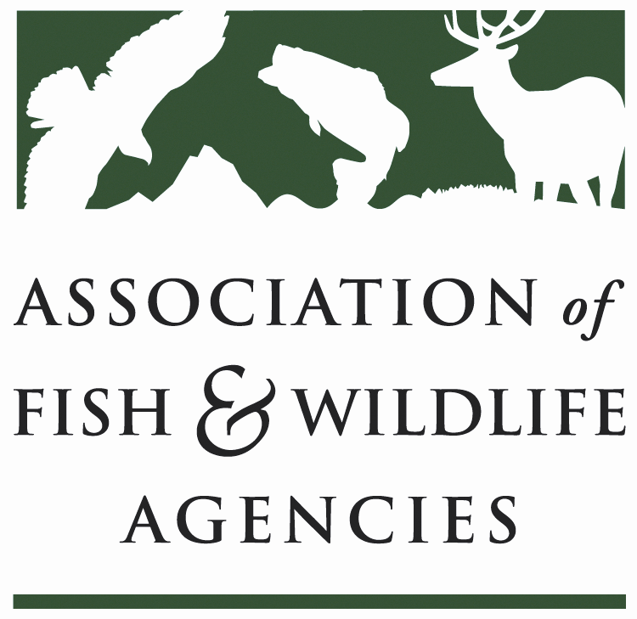

OCEAN RESOURCES POLICY COMMITTEE
Chair: Nate Pamplin (WA)
Vice-Chair: VACANT

Tuesday, March 21, 2023
8:00AM CT – 10:00 AM CT

88th North American Wildlife and Natural Resources Conference
St. Louis, MO
Majestic B – Conference Center Upper Level
Cynthia Martinez FWS
???
Dave Miko FWS
Gary Whelan MI
Justine Hasz WI
Lance Hebdon ID
Heidi Lovett NOAA
Dave Hu USGS
David Lind AFWA
Nate Pamplin WA
Mike Leonard ASA
Doug Austen AFS
Hugh Morrison Regional Director Pac Region USFWS
Jacob Blandford AFWA
Glenn Hughes ASA
Jennifer Cippoletti ABA

8:00 am Call to Order/Introductions/Review Agenda – Nate Pamplin, WDFW
- Action: Approval of Draft Meeting Agenda/September 2022 minutes
  - Gary Whelan Moved, Justine Hasz Second
    - Passed unanimous

8:10 am MSA/MMPA Updates – Mike Leonard, ASA
- Reauth lasted until 2013, existing statute since then =
- Multipel attemps to reauth, none of which made it passed one chamber.
  - Don Young R bill, Huffman D bill
    - Huffman listening sessions, focus on climate ready fisheries
  - Likely we see individual pieces move – things like driftnet mod, fishery disaster reform
- Talk of noaa organic act – Cantwell draft, large bill
  - 10 pg over in House –
  - Likely we see more movement there than on MSA
- No traction on Westerman MMPA pinupheads amendment

8:25 am Bipartisan Infrastructure Law/Inflation Reduction Act Implementation
- NOAA – Heidi Lovett, NOAA
  - $891M over 5 yrs for habitat restoration
    - $491M for hab rest and resilience
    - $400M for fish passage
    - Up to 15% reserved for Indian tribes
    - Monies can also be used for technical assistance
    - 36 New Projects
    - Announcements later this year – transformational habitat restoration
    - Nothing on IRA
- USFWS – Dave Miko, USFWS

- USGS – TBD

8:40 am Federal Partner Updates
- Action: Approval of Draft Meeting Agenda/March 2022 minutes
- NOAA – Heidi Lovett, NOAA
  - National Saltwater Recreational Fisheries Policy
- ANOPR coming very soon on natl standards 4, 8, and 9
  - Right Whale Vessel Strike Reduction Rule
    - Over 90k comments, expect final action soon
- Nate – Want to have convo w/ NOAA and USFWS on manner in which states apply section 6 grants. Real partnership w/ USFWS in terms of priorities identified, where funds going – Contrast w/ NOAA side, very HQ driven.
- USFWS – Dave Miko, USFWS
  - Sport Fish and Boating Partnership Council
    - FACA that in past advises DOI on fish/wildlife issues – ACE Act added DOC reporting.
    - Expect charter signed any time – Once happens FR will go out soliciting board nominees
- USGS – Dave Hu
  - Assembled team of water scientists including CRUs, finishing drafts on 2 initaitives to help guide USGS science focus –
    - One on forage fish – Encompasses food web interdynamics, energetics, a lot of metabolism seeing transferred through different systems – Goes into predator/prey business. Excited to engage NOAA as next step.
    - Other one on adult Chinook – Food web, predator/prey, trends in fish health.
    - Finishing internal draft then engage partner agencies 1-on1. Happy to share with state agencies one on one – cant distribute to all but happy to share individually
  - Continue support for regional commissions.
  - Conservation aquaculture – Herring stock work, different fish health efforts. New area but looking to expand.
  - Interest in native lamprey and sturgeon – Navigating internally.
  - NFHP – Active role on data/sci comm via Dan Weifriech
- Will make plan for 3DHP – Will run into difficulties as drop down to scale. Will start beta testing when Board approves how to bring it in.

9:00 am National Fish Habitat Partnership Update – Gary Whelan/Ryan Roberts

9:10 am Government Affairs Update – David Lind, AFWA/ All
- FY24 Appropriations/Priorities – David Lind, AFWA/ All
National seafood council sunset, but law still on the books. Congress wants to see seafood council again. Report due internally next month.
Check in with Kathleen Hartman

9:30 am BOEM Offshore Wind Energy Proposal

Comment on impacts to longstanding whiteship surveys, stock assessments. Marine fisheries commissions putting in letters. Hope to coordinate with intergovernmental forums reinforcing that method.
Include a sentence indicating our concern over always wanting to locate on highest quality fish habitat – GL had to deal with before everyone else. Placement of surveys on critical fish habitats.

9:50 am Vice-Chair Recommendations – All

9: 55 am Wrap-up and Adjourn – Nate Pamplin, WA

Action items –
BOEM comment extension, comments
Reach out to reg fishery commissions
USWS/NOAA Sec 6 grants
Approps request discussion draft

Committee Charge:
Focus Areas and Goals:
- Identify, support, and communicate science, legal, policy and public involvement issues related to water that are of importance to fish and wildlife.
- Support and build on recommendations from AFWA Drought Forum.

