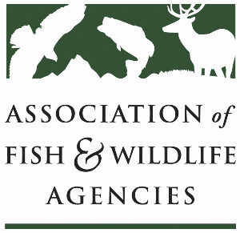

**Subcommittee on Water**

Chair: Julie Carter (AZ)

Vice-Chair: Bob Caccese (PA)

Monday, September 23, 2024

1:00 PM-2:45 PM

114th Association of Fish & Wildlife Agencies Annual Meeting

Madison, Wisconsin

**Agenda**

1:00 pm Call to Order/Review Agenda/Approval of Minutes – *Julie Carter, AZ*

1:05 pm Introductions – *All*

1:10 pm Virtual Pre-Meeting Recap – *Julie Carter (AZ)*

1:20 pm Government Affairs Update – *Ali Schwaab (AFWA)*

1:35 pm Cold Water Releases in the Colorado River – *Julie Carter (AZ)*

1:50 pm Roundtable on State Water Quantity and Quality Issues *– All*

2:20 pm Federal Partner Updates

2:40 pm Wrap-up Discussion and Adjourn – *Julie Carter (AZ)*

* Action items for FWRPC