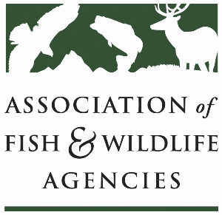

**Fisheries and Water Resources Policy**

Chair: Jim Fredericks (ID)

Vice-Chair: Craig Bonds (TX)

Wednesday, September 25, 2024

9:00 AM – 11:45 AM

114th Association of Fish & Wildlife Agencies Annual Meeting

Madison, Wisconsin

**Agenda**

9:00 am Call to Order/Review Agenda/Approval of Minutes – *Jim Fredericks, ID*

9:05 am Introductions - *All*

9:10 am Subcommittee and Working Group Reports

* Subcommittee on Water – *Julie Carter, AZ*
* Drug Approval Working Group – *Alan Johnson, IA*
* Fish & Wildlife Coordination Act Working Group – *Jen Sheehan, AR*
* Update on Aquatic Animal Health and Aquaculture Working Group Establishment – *Jim Fredericks, ID*

9:30 am Government Affairs Update – *Ali Schwaab, AFWA*

9:45 am Consider Resolution to Support the Instream Flow and Water Level Conservation Training Center Concept – *Jim Fredericks, ID*

9: 50 am National Fish Habitat Partnership Update – *Ryan Roberts, AFWA*

10:10 am Break

10:25 am Recommendations to AFS Regarding Names of Fishes Process – *Julie Carter, AZ*

10:30 am Rotenone Update and Discussion – *All*

10:50 am Roundtable on AFWA Fisheries and Water Priorities for Next Administration – *All*

11:10 am Federal Partner Updates

* USFWS Update – *Dave Miko, USFWS*
* USGS Update – *Dave Hu, USGS*
* NOAA Update – *Heidi Lovett, NOAA*
* BLM Update – *Sharmila Premdas Jepsen, BLM*

11:40 am Wrap-up Discussion – *Jim Fredericks (ID)/All*

11:45 pm Adjourn