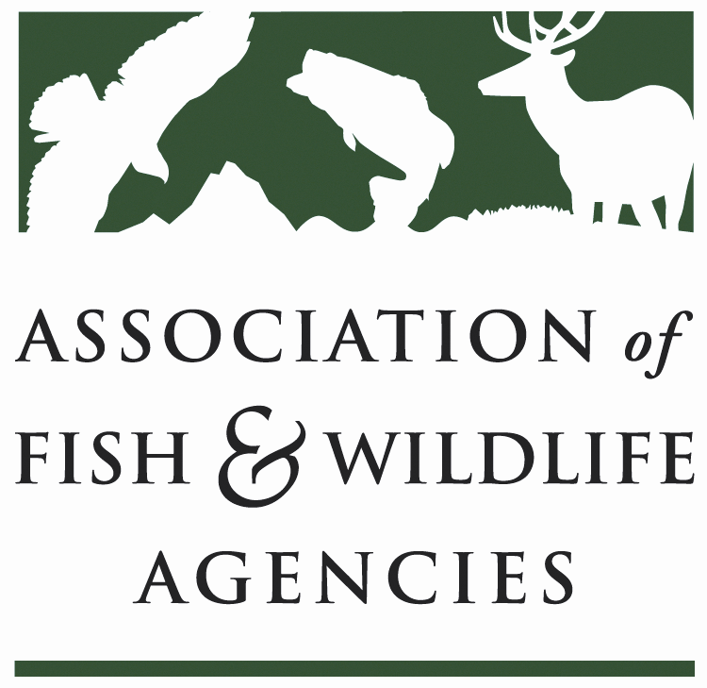

Teaming with wildlife Committee
Chair: Carter Smith (Texas)
Vice Chair: David Whitehurst (Virginia

Thursday, March 9, 2017
8:00 am to 12:00 pm

North American Wildlife and Natural Resources Conference
Room: Terrace Room East / Davenport Grand Hotel
Spokane, WA

Committee Charge Advocate for long-term dedicated funding and annual appropriations for the conservation of at-risk fish and wildlife, nature-based recreation and conservation education; support development, implementation and revision of State Wildlife Action Plans; build, support and coordinate the national Teaming With Wildlife coalition.

Agenda

08:00 AM Call to Order/Review Agenda (David Whitehurst, VDGIF)

08:05 AM Introductions (David Whitehurst, VDGIF)

08:15 AM Approval of Committee Report from the September 2016 Meeting (David Whitehurst, VDGIF)

08:20 AM State & Tribal Wildlife Grants (Mark Humpert, AFWA)
    - Legislative Update
    - 2017 Fly-in
08:35 AM Discuss Recommendation to Change Committee Name to Wildlife Diversity Conservation & Funding Committee (Rex Sallabanks, IDFG)

09:15 AM State Wildlife Action Plans
- Report from Review & Revision Guidance Working Group (Rex Sallabanks, IDFG)
- National SWAP Meeting (Mark Humpert, AFWA)
- New Farm Bill & SWAP (Andrew Schmidt, AFWA)

10:00 AM -BREAK-

10:15 AM Blue Ribbon Panel on Sustaining America’s Diverse Fish & Wildlife Resources
- Communications & Branding (Sean Saville, AFWA)
- Legislative Update (Jen Mock Schaeffer, AFWA; Naomi Edelson, NWF)
- Grass Roots Advocacy (Sean Saville, AFWA)
- Agency Relevancy & Transformation Working Group (Steve Williams, WMI)
- Report from Education, Outreach & Diversity/Teaming With Wildlife Blue Ribbon Panel Joint Working Group (Keith Norris, TWS)

11:30 AM Wildlife TRACS (Tim Smith, USFWS)

11:45 AM Other Topics
- Midwest Regional Monarch Plan-Naomi Edelson (NWF) and Ed Boggess (MAFWA)

12:00PM Adjourn

