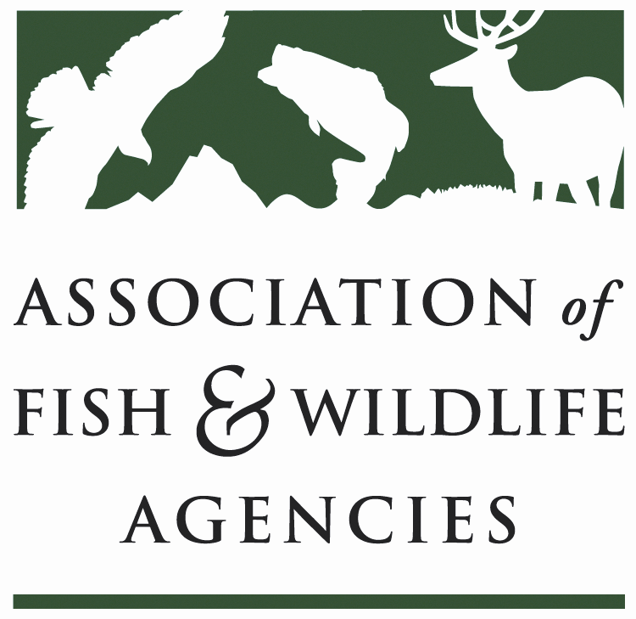

Teaming with wildlife Committee
Chair: Carter Smith (Texas Parks and Wildlife Department)
Vice Chair: David Whitehurst (Virginia Department Game & Inland Fisheries)
Tuesday, September 13, 2016
8:00 am to 12:00 pm
AFWA Annual Meeting
Room: 411-412 Marriott Philadelphia Downtown.
Philadelphia, PA

Committee Charge Advocate for long-term dedicated funding and annual appropriations for the conservation of at-risk fish and wildlife, nature-based recreation and conservation education; support development, implementation and revision of State Wildlife Action Plans; build, support and coordinate the national Teaming With Wildlife coalition.

Agenda

08:00 AM Call to Order/Review Agenda (Carter Smith, TPWD)

08:05 AM Introductions (Carter Smith, TPWD)

08:15 AM Approval of Committee Report from the March 2016 Meeting (Carter Smith, TPWD)

08:20 AM State & Tribal Wildlife Grants (Mark Humpert, AFWA)
08:30 AM Blue Ribbon Panel on Sustaining America’s Diverse Fish & Wildlife Resources
- Introduction of Mr. Sean Saville, new Blue Ribbon Panel Campaign Mgr. (Carter Smith, TPWD))
- Discussion of the Panel’s Recommendations and Working Groups
  - Agency Relevancy & Transformation (Carter Smith, TPWD)
  - Legislation-Recovering America’s Wildlife Act-HR5650 (Mark Humpert, AFWA)
  - Joint Working Group With the Education, Outreach Diversity Committee (Keith Norris, TWS and David Whitehurst, VDGIF)
- Advocacy and Campaign Plan (Sean Saville, AFWA)
- ACTION ITEM-Resolution Supporting Blue Ribbon Panel (Carter Smith, TPWD)
- Discussion of Next Steps and Action Items for Committee Members (Mark Humpert/Sean Saville (AFWA)

10:00 AM -BREAK-

10:15 AM State Wildlife Action Plans
- Revision Guidance (Rex Sallabanks, IDFG)
- SGCN Tool (Mark Humpert, AFWA)
- Feature Edition in TWS Wildlife Professional (Keith Norris, TWS)
10:45 AM Report on Wildlife & Sport Fish Restoration Program
- Leadership Changes at WSFR (Paul Rauch, USFWS)
- Status of State Wildlife Action Plan Revisions (Paul Rauch, USFWS)
- Update on Wildlife TRACS (Tim Smith, USFWS; Jon Gassett, WMI)
11:15 AM 2016-2017 Committee Work Plan/Potential Committee Name Change (David Whitehurst, VDGIF)

11:45 AM Other Topics

12:00PM Adjourn

