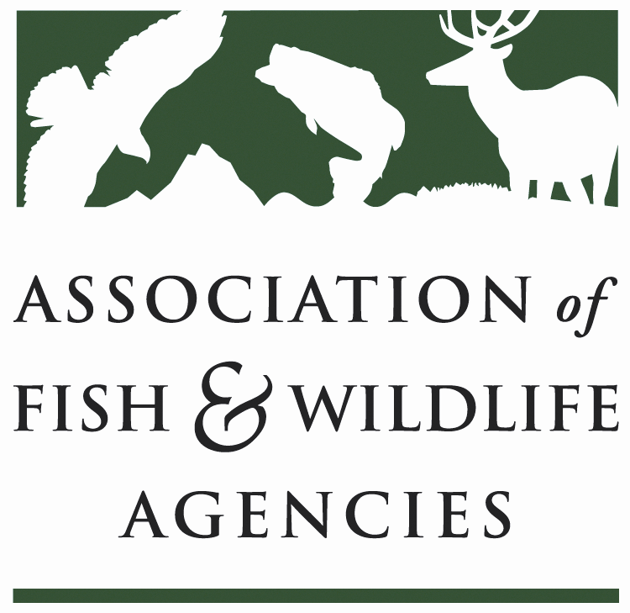

Energy & wildlife policy Committee
Chair: Paul Johansen (WV)
Vice-Chair: Keith Sexson (KS)

Tuesday, September 12, 2017
1:00 – 5:00pm

AFWA Annual Meeting
Maybird Room
Sandy, UT

Meeting Minutes

- Call to Order – Chairman Paul Johansen, WV
Reviewed and Approved Agenda
Committee voted to approve of minutes from the March 9, 2017 Meeting

- Committee Workplan and Energy Needs Assessment - Davia Palmeri, AFWA

- State Roundtable – Full Committee

  - West Virginia- Interstate gas transmission is a huge issue for us right now. We are working on related mitigation options. There is also a Marcellus shale play for which we are dealing with FERC
  - Utah - Oil and gas have been a lot slower in recent years, but we are already experiencing an upturn. We are also working on 2 big transmission projects.
  - Kansas - We are working on a lot of new wind. Having a lot of issues getting the companies to the table to share information up front about proposed developments. We are drafting an updated wind position statement for the state (it is currently with the Governor’s office).
  - New Mexico – Engaging with wind energy companies related to Lesser Prairie Chicken habitat. Gas is alive and well in New Mexico.
  - North Dakota- We are dealing with oil and gas, wind, and coal. Game and Fish is focused on mitigating impacts to ecological sites. We worked with some companies on voluntary mitigation framework and we are putting together a resource layer that puts a value on resources. Thinking about the CHAT model.
  - Texas – We are just starting to be brought to the table with wind developers. We’ve seen an uptick in frack sand mining in Dunes Sagebrush lizard habitat, which was not listed a few years back based on the Texas Conservation Plan. Working with the comptroller to try to get compliance with that plan to protect the lizard habitat.
  - Wyoming – We have a lot of wind energy in south central Wyoming. WY reported to this committee in March on core Sage Grouse Habitat. We do have a proposal for wind siting in the core area. WY recommended that BLM not permit it. In southcentral Wyoming we have a large wind farm proposed in pronghorn habitat. Trying to plan a large scale research project to see if we can develop mitigation actions. We are also dealing with raptors and incidental take.
  - Arizona – We are looking to develop a companion permit for the FWS’s Eagle incidental take rule. We are looking for other states that may also be working on this!
  - Nebraska – Working on the Sand Hills Transmission line. Wind has become very prevalent in the state and we are trying to avoid Whooping Crane critical habitat. There is a southeastern company pushing to run ethanol for cellulosic energy and we are reviewing Florida’s rules as a model.
  - Colorado – Transmission lines are proposed across Gunnison Sage Grouse critical habitat.

- Report from Bioenergy Working Group -Eric Zach, Working Group Chair

- AFWA sent support letters for 2 DOE nominations for the Biomass Technical Advisory Committee. Our supported nominees were Aviva Glazer from NWF and Susan Rupp from Enviroscapes Consulting.
- There was a recent paper that quantified grassland loss near US Ethanol refineries. The Renewable Fuels Standard has land conversion prohibitions but that does not seem to be stopping conversion. We are working on a white paper on land conversions related to refineries.
- AFWA has hired a six month long contract Biofuels Liaison position to do outreach to the industry. She will attend conferences and meetings to discuss the potential effects of bioenergy on wildlife. She will also revise factsheets that were created during the last Farm Bill reauthorization.
- We’d like to step up our community’s understanding of biofuels issues by hosting a webinar through this committee.
- No action items

- 2018 National Conservation Need Proposal - Russell Norvell, Pacific Flyway Nongame Technical Committee
  - The Pacific Flyway Nongame Technical Committee is interested in sending an NCN through this committee to stimulate research on migration and stopover patterns that will be able to accurately inform wind, solar, and transmission siting decisions (see slides).
  - This committee typically submits an NCN to support an Energy Program Manager position at AFWA.
    - Chair will convene a small group to review last year’s NCN, which was not selected by the Grants Committee, and propose changes that may broaden the scope to incorporate potential research topics related to energy but still best serve the committee.
    - Russ will share a copy of their draft NCN with the committee
    - Committee members will have the opportunity to provide feedback in advance of the North American and MSCGP NCN process.

- AFWA Legislative and Administration updates - AFWA Government Affairs Staff
  - Hydropower Modernization Act of 2017 (H.R. 3034)
    - On June 28th, the House Energy and Commerce Committee advanced the Hydropower Modernization Act of 2017 (H.R. 3034). This language, although improved from the Hydropower provisions found last session in H.R. 8, still contains concerning provisions regarding extension and alteration of timelines for permitting, licensing, and ESA biological opinions as well as for federal agencies with regard to fishway prescriptions and section 4(e) authority. AFWA will continue to work with key members of the House on these concerns as the bill advances through the House of Representatives.

  - Energy and Natural Resources Act of 2017 (S. 1460)
    - Sen. Murkowski (AK), Chair, and Sen. Cantwell (WA), Ranking Democrat, Energy and Natural Resources (E/NR) Committee have introduced S. 1460, a bipartisan bill with comprehensive energy and natural resources titles. It very closely mimics the bipartisan energy bill from both Senators in the last Congress that was close to being reconciled in Conference Committee with the House energy bill when Congress adjourned sine die. S.1460 includes natural resource provisions as well as language to expedite hydropower licensing and relicensing processes. We are pleased to report that language in S. 1460 is more refined than S.2012 of last session with regard to the required use of relevant and current data during hydropower licensing and relicensing proceedings and no longer contains unfunded mandates to the states to produce annual reports to Congress or maintain a publicly accessible database on all hydropower licensing and relicensing proceedings.
    - The Natural Resources Division of S. 1460 also contains numerous provisions from the Energy package last session as well as the Bipartisan Sportsmen’s Act (S. 733) which the E/NR Committee already sent to the floor. The Senate Majority Leader invoked Senate Rule XIV to bypass Committee referral and send S.1460 directly to the floor for consideration. The bill has yet to be considered by the full senate.
    - AFWA staff will continue to work with members of Congress to ensure final language governing hydropower supports state authority, objectives and sound management of aquatic resources.

  - Implementing an America-First Offshore Energy Strategy (EO 13795; signed April 28, 2017)
    - Directs the Secretary of the Interior to revise or initiate a new 5-year plan that considers access to areas that the Obama Administration prohibited.
    - Reverses President Obama’s withdrawal of the Arctic OCS Planning Areas, and several other areas. Some withdrawals were left in place, such as the North Aleutian Basin.
    - Encourages DOI and the DOC to work together to come up with a more streamlined seismic surveying process.
    - Directs DOI to reconsider several regulations that have been finalized recently.
    - Directs Commerce to refrain from designating or expanding any National Marine Sanctuary under the National Marine Sanctuaries Act, unless the sanctuary designation or expansion proposal includes a full analysis of any energy or mineral resource potential within the designated area and the potential impact the proposed designation or expansion will have on the development of those resources.
    - Within 180 days, conduct a review of all designations and expansions of National Marine Sanctuaries, and of all designations and expansions of Marine National Monuments under the Antiquities Act of 1906 designated or expanded within the 10-year period prior to the date of this order.
    - On July 26th NOAA reopened the comment period on marine sanctuaries and monuments. They accepted these comments until August 15th and are in the process of reviewing them currently.

  - Migratory Bird Treaty Act
    - Incidental take of migratory birds under the Migratory Bird Treaty Act has been inconsistent across FWS regions.
    - Multiple federal courts have weighed in. 2 courts have ruled that FWS does have the authority to regulate incidental take. 2 courts have ruled that they do not.
    - In January of 2017, the Obama Administration released a Solicitor’s Opinion laying out the legal framework that supports the concept that FWS does have this authority. This opinion was suspended quickly after the beginning of the Trump administration.
    - Multiple players in the wind industry, the Energy Wildlife Action Coalition, would like to see certainty about incidental take. They are considering pursuing an opposing solicitor’s opinion and moving through the courts, but not ruling out approaching amendments to MBTA.
    - There is discussion of a payment in lieu of mitigation option or a NRDA type program for migratory bird take.
    - AFWA will continue to monitor this and is ready to engage the states through this committee and the AFWA Bird Conservation Committee if there is movement either way.
    - Discussion
      - The “write a check” approach falls to others to do the work
      - Need to recognize that mitigation takes work, not just money

  - FWS Mitigation Policy
    - Gary Frazer updated the committee on the fact that a recent E.O. and S. O. direct FWS to revisit the recently revised mitigation policies that were finalized in late 2016. The orders referenced concern with the “net conservation gain” goal laid out by the previous administration. There should be more news on this in the next few months

Coffee Break

- Worldwide Standard for Automatic Bats & Birds Fatality Monitoring -
Michal Przybycin, Empeko S.A.
  - The committee heard a presentation from a Polish company that is developing an automatic system of monitoring for fatalities at wind turbines
  - See slides for materials.
  - The committee requests that they continue to be updated as this technology develops.

- Use of Ultrasonic Deterrents to Reduce Bat Mortality at Wind Plants - Brogan Morton, NRG Systems

  - The committee heard a presentation about a new approach to deterring bats from interacting with wind turbines.
  - See slides for materials.

- Alliance for America’s Fish and Wildlife - Sean Saville, AFWA
  - The Alliance materials are now live on OurNatureUSA.com
  - The Recovering America’s Wildlife Act is not currently set to access royalties from renewable energy on federal land
  - There is a great opportunity for members of this committee to promote the new funding concept to energy industry partners in face-to-face meetings.

- Report from American Wind Wildlife Institute - Ian Evans, AWWI
  - AWWI welcomed Paul Johansen on to their Board of Directors this year as the representative for AFWA.
  - AWWI is focused on understanding and minimizing risk to wildlife from wind energy
  - We have a variety of reports available on our website: https://awwi.org/
  - We have developed the AWWIC library that allows you to search through peer-review wind-wildlife research, published articles and reports, and publicly available but un-published reports prepared for wind energy facilities in North America: https://awwic.nacse.org/library.php

- Report from U.S. Geological Survey’s Energy Programs - Mona Khalil, USGS
  - USGS recently released the Energy and Wildlife Research Annual Report for 2017: https://pubs.er.usgs.gov/publication/cir1435
  - See slides for details of numerous research papers by USGS scientists in 2017

- Report from Bat Conservation International - Mylea Bayless, BCI
  - The Bats and Wind Energy Cooperative (BWEC) recently released their next newsletter: http://www.batsandwind.org/pdf/BWECe-NewsletterJuly2017_v19.pdf
  - AFWA, ABC, and BCI are working on revising the wind power siting guidelines document.
  - BCI is collaborating with USFS on Research and development of an acoustic monitoring portal to combine data on bat locations and activities
  - Working on thermal video research to understand bat behavior with USGS and the University of Hawai’i
  - See slides for details.
- Adjourn!

