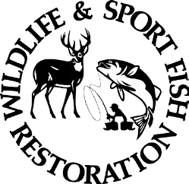
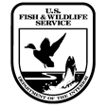
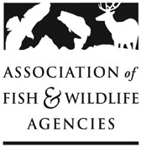

2025 Multistate Conservation Grant Program Announcement

**Submission Deadline: June 7, 2024, no later than 11:59 PM EDT **

GRANT PROPOSAL

PROPOSAL DETAILS.
Descriptive Title:
Organization:
Recipient Location:
Grant Start Date: | January 1, 2025 | Grant End Date:

PROJECT ABSTRACT SUMMARY/PUBLIC DESCRIPTION. Please follow the instructions provided in the MSCGP Full Proposal Guidelines:

GRANT RECIPIENT CONTACT(S). List full name, title, phone number, email address, and organization name for the following:
  - Primary Principal Investigator of the recipient Organization
  - Primary Authorizing Official of the recipient Organization

ELIGIBILITY INFORMATION.
- Organization Type. Select one of the following:

  - State or group of States
  - A nongovernmental organization.
  - Public Institution of Higher Education
  - The United States Fish and Wildlife Service, or a State or group of States, for the purpose of carrying out the National Survey of Fishing, Hunting, and Wildlife-Associated Recreation

- Beneficiary Information. The project must benefit at least one of the following. Please choose one of the following categories that best describes the geographic scope of the project:

- Project benefits at least 26 states. Using states’ abbreviations, please list all states that will benefit.
- Project benefits a majority (over 50%) of the States in a U.S. Fish & Wildlife Service Region that will benefit. List the States in each Region that will benefit (use State abbreviations).
- Project benefits a majority (over 50%) of the States belonging to a regional association of State fish and wildlife agencies (click each of the Associations for the state members, WAFWA, MAFWA, NEAFWA, SEAFWA, Please indicate the regional fish and wildlife association that will benefit and list the States in each region that will benefit (use State abbreviations).

- The Strategic Priority Addressed. Please refer to the 2025 AFWA Strategic Priorities and list the ones your proposal addresses.

- Eligibility: Is your project eligible according to the Eligibility Standards for activities/species eligibility described in the 2025 Full Grant Proposal Guidelines?

- Yes
- No

- Funding Program(s). Identify grant program(s) relevant to your proposal:

- Traditional Multistate Conservation Grant Program – Wildlife Restoration (T-MSCGP WR)
- Modern Multistate Conservation Grant Program – Wildlife Restoration (R3-MSCGP WR)
- Traditional Multistate Conservation Grant Program – Sport Fish Restoration (T-MSCGP SFR)

PROJECT STATEMENT. Complete each section below following instructions provided in the MSCGP Full Grant Proposal Guidelines. Use the separate Budget Table and Budget Narrative templates for budget information and submit as a separate file.
- Need:

- Purpose:

- Objectives:

- Approach:

- Results or Benefits Expected:

- Deliverables:

- Timeline:

- Monitoring and Evaluation:

- Qualifications of Key Personnel:

