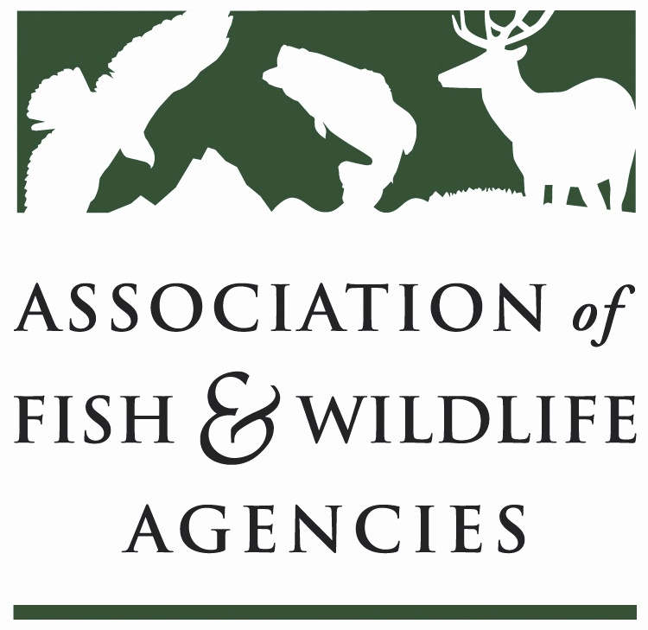

FEDERAL AID COORDINATORS WORKING GROUP
Chair: Matthew Warriner (AR)
Vice-Chair: Marianne Cox (AZ)

March 25, 2024
3:00 PM – 5:00 PM

Agenda

3:00 pm Call to Order/Review Agenda/ Introductions
Matthew Warriner, Arkansas Game and Fish Commission

3:10 Working Group Report
Matthew Warriner, AGFC and Marianne Cox, Arizona Fish and Game Department

3:20 Real Property
- Monitoring and Reporting Best Management Practices
Stacy Xenakis, Ohio Department of Natural Resources
- Status Reporting
Scott Knight, U.S. Fish and Wildlife Service

3:40 Subaward Management Best Management Practices
Amy Silvano, Alabama Department of Conservation and Natural Resources

3:50 Regulations Update
Diana Swan-Pinion, U.S Fish and Wildlife Service

4:00 Wildlife and Sport Fish Restoration (Office of Conservation Investment) Update
Matt Filsinger, Kathy Hollar and Scott Knight, U.S. Fish and Wildlife Service

4:20 TRACS Update
Craig Kelling, U.S. Fish and Wildlife Service

4:45 Future Meetings
New Business
Review of Action Items

4:55 Wrap Up/Adjourn

