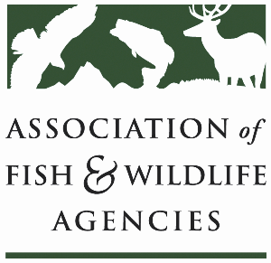

SUBCOMMITTEE ON WATER
Chair: Julie Carter (AZ)
Vice-Chair: Robert Caccese (PA)

Date: Tuesday, March 26, 2024
Time: 1:00 PM – 3:00 PM EDT
Amway Grand Plaza
89th Wildlife and Natural Resources Conference
Grand Rapids, MI

Subcommittee Charge: Identify, support, and communicate science, legal, policy and public involvement issues related to water that are of importance to fish and wildlife; and to support and build on recommendations from AFWA Drought Forum.

Agenda

1:00 pm Call to Order/Review Agenda/Approval of Minutes/Committee Charge – Julie Carter, AZ

1:05 pm Introductions – All

1:10 pm Virtual Pre-Meeting Recap – Julie Carter (AZ)

1:25 pm Roundtable on State, Province, and Partner Water/Drought Issues – All

1:50 pm Instream Flow and Water Level Conservation Training Center Update

2:05 pm Roundtable on Water Quality Issues- All
- Microplastics, PFAs, etc.

2:20 pm Government Affairs Update – Ali Schwaab, AFWA
- Project Partnership Agreement (PPA) Reform
- WRDA 2024
- ICWP/WSWC Policy Roundtable Recap

2:35 pm Federal Partner Updates

2:50 pm Wrap-Up Discussion – Julie Carter (AZ)
- Action items for FWRPC

3:00 pm Adjourn

AFWA SOW Background Companion Slides (Virgil Moore)
https://www.instreamflowcouncil.org/download/virgilmoore_slides_flow2018-pdf/?wpdmdl=11389&ind=5ccff16ab72bd

AFWA SOW Background Dialogue (Virgil Moore)
https://www.instreamflowcouncil.org/download/virgilmoore_dialogue_flow2018-pdf/?wpdmdl=11387&ind=5ccff167db4da

