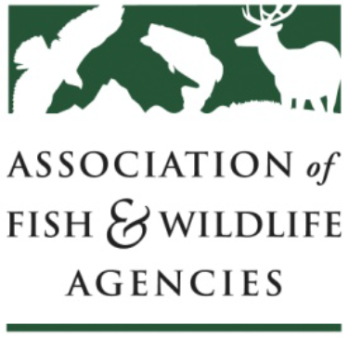
AFWA Committee Work Plan
Worksheet

Subcommittee / Workgroup / Task Force Work Plan
Date: 11/30/22
Subcommittee Name: Subcommittee on Water
Chair: Jason Olive | Vice Chair: Robert Caccese |  | Staff: David Lind (Temporary)
Subcommittee Charge:
- Identify, support, and communicate science, technical, legal, institutional, policy and public involvement issues related to water that are of importance to fish and wildlife.
- Support and build on recommendations from AFWA Drought Forum.
Changes to the Charge:
None made at this time.
List Major Activities and Objectives Accomplished During the Last Year:
- Completed a review of the 2021 USGS 50 state Stream Gage Gap Analysis, and provided access to reports, presentations, and updates for members via a shared Google Drive folder.
- Advanced the creation of an Instream Flow & Water Level Conservation Training Center through collaboration with IFC and AFS.
- Hosted a presentation by USGS on their transition to the new 3D HP hydrography dataset, and interim plans for NHD+ data availability.
- Led AFWA collaboration in support of increased USGS stream gage funding.
- Co-hosted presentation on proposed FERC hydropower reform legislation.
- Upon request, provided input to AFWA leadership on water related legislation and regulatory actions.
- Processes to improve coordination with other AFWA committees were developed, and will be implemented in 2023.
List Activities and Objectives that will be Accomplished in the Coming Year:
- Advocate for a USGS 50 state water temperature gaging gap analysis.
- Explore additional opportunities for collaboration with other AFWA committees to strengthen efforts pursuing shared interests.
- Monitor and respond to developments related to WOTUS litigation and rulemaking.
- Monitor and advise AFWA leadership on drought related fish, wildlife, and habitat mitigation issues (e.g., Colorado River basin compact decisions) and potential impacts to aquatic fauna and waterway access.
- Maintain and update online resources for SOW members and other interested parties.

Describe any Changes you Anticipate to the Work Group:
None at this time.
List Workgroup Members:

State and Provincial:
Jason Olive (AR)
Robert Caccese (PA)
Gary Whelan (MI)
Peter Aarrestad (CT)
Christopher Cantrell (AZ)
Kevin Mayes (TX)
Eric Nagid (FL)
Dirk Miller (WY)
John Lott (SD)
Joe Klein (AK)
Chris Goudreau (NC)
Michael Garrity (WA)
Jennifer Sheehan (AR)
Matt Nicholl (CO)
Todd Richards (MA)
Andy Clark (AZ)
Alan Osterland (WY)
Lynn Quattro (SC)
Dennis Riecke (MS)
Thomas Bassista (ID)
Lori Ann Riggin (SC)
Andy Brummond (MT)
Jason Persinger (MO)
Julie Carter (AZ)

Federal and Partner:
S. Miller (BLM)
P. Cutillo (BLM)
David Hu (USGS)
Scott Barndt (USFS)
Douglas Austen (AFS)
Drue Winters (AFS)
Mark Biddlecomb (DU)
Christopher Estes (Life Member)
Matt Heinemann (DJ Case)

Date Workgroup Formed: 2016 |  | Expected Termination Date: N/A
Comments
The subcommittee continues to fulfill its charge, providing the critical technical expertise and collaborative space needed for engagement on specialized water issues. It has continued to expand the perspectives and partnerships brought to the table, identifying more opportunities to increase communication and facilitate effective policy to fulfill the needs of state agency resource managers.

