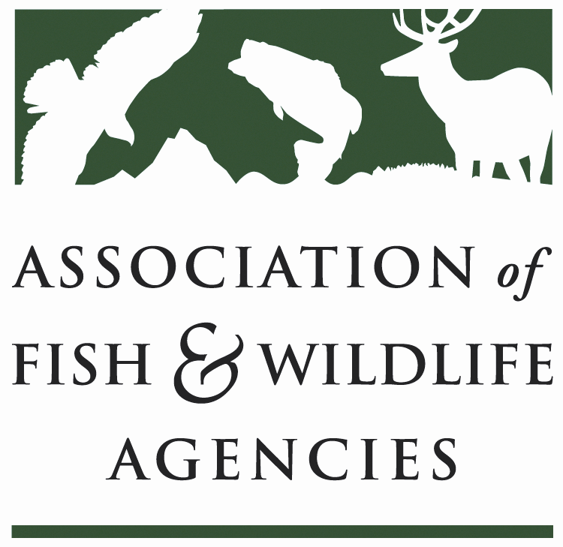

Fisheries and WATER RESOURCES POLICY COMMITTEE
Chair: Jim Fredericks (ID)
Vice-Chair: Craig Bonds (TX)

Date: Wednesday, September 27, 2023
Time: 9:00AM-12:00PM MDT

113th Association of Fish & Wildlife Agencies Annual Meeting
Calgary, Canada

Agenda

9:00 am Call to Order/Review Agenda/Approval of Minutes – Jim Fredericks (ID)

9:05 am Introductions - All

9:10 am Subcommittee and Working Group Reports
- Subcommittee on Water – Julie Carter, AZ
- Drug Approval Working Group – Alan Johnson, IA
- Bird & Fish Related Conflict Working Group – Justine Hasz, WI
- Fish & Wildlife Coordination Act Working Group – Jen Sheehan, AR

9:25 am BIL/IRA Federal Implementation Updates
- USFWS – David Miko
- NOAA – Heidi Lovett
- FHWA Culvert AOP Program – Daniel Buford

9:50 am Canadian Aquatic Connectivity – Dr. David Browne

10:10 am National Fish Habitat Partnership Update – Robert Boyles, SC / Ryan Roberts, AFWA

10:30 am Break

10:40 am Developing Standard AIS Inspection Guidelines for Hatcheries – Josh Leonard, WY

10:55 am USFWS Update – Dave Miko, USFWS
- Internal program reviews
- Hatchery rehab work
- Bsal Final Rule

11:10 am USGS Update – Melanie Steinkamp, USGS
- Freshwater Mussel Research Strategy

11:25 NOAA Update – Heidi Lovett, NOAA
- ANPR on implementing guidelines for National Standards 4, 8 & 9
- Right whales & Rice’s whales

11:40 Legislative/Regulatory Update – Ali Schwaab (AFWA)

11:50 Wrap-up Discussion – Jim Fredericks (ID)/All

12:00 Adjourn

