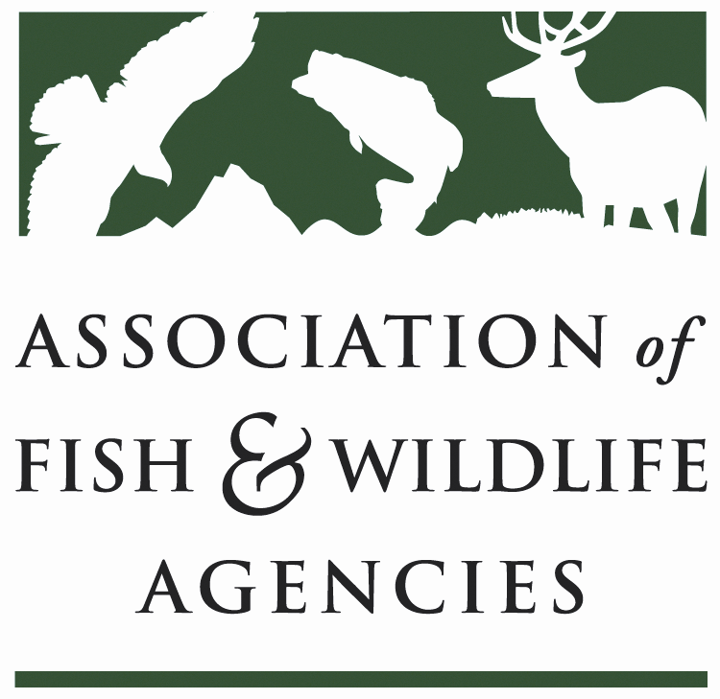

Ocean RESOURCES POLICY COMMITTEE
Chair: Nate Pamplin (WA)
Vice-Chair: Dave Golden (NJ)

Date: Tuesday, September 26, 2023
Time: 10:00 AM – 12:00 PM MDT

Calgary, Canada

Agenda

10:00 am Call to Order/Review Agenda/Approval of Minutes – Nate Pamplin (WA)

10:05 am Introductions - All

10:10 am BIL/IRA Implementation
- NOAA Office of Habitat – Heidi Lovett, NOAA

10:30 am NOAA Update– Heidi Lovett, NOAA / Angie Somma, NOAA
- ANPR for potential updates to National Standards 4, 8, and 9
- Procedural directive to guide application of MSA 304(f)
- MRIP FES Pilot Study Webinar
- Right whale vessel speed rule
- Rice’s whale critical habitat and petition to establish vessel speed rule

10:50 am National Fish Habitat Partnership Update – Robert Boyles (SC) / Ryan Roberts, AFWA

11:10 am Government Affairs Update - Ali Schwaab, AFWA / Beth Callaway, ICWP
- Legislative Updates
- Open Funding Opportunities

11:30 am Roundtable Discussion and Wrap up – Nate Pamplin (WA) / All

12:00 pm Adjourn

