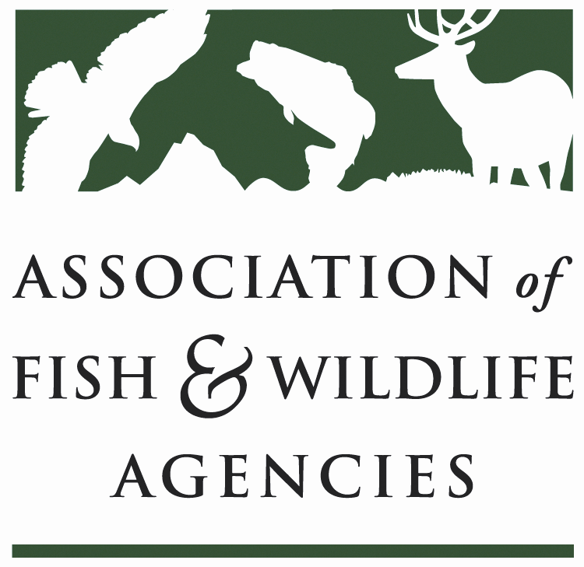

SUBCOMMITTEE ON WATER
Chair: Julie Carter (AZ)
Vice-Chair: Robert Caccese (PA)

Date: Friday, September 15, 2023
Time: 1:00 PM – 3:00 PM EST

Virtual Meeting

Agenda

1:00 pm Call to Order/Review Agenda/Approval of Minutes – Julie Carter (AZ)

1:05 pm Introductions - All

1:10 pm USGS Gap Analysis and Hydrography Update - C. Estes, Life Member

1:30 pm IFC/AFS Instream Flow & Water Level Conservation Training Center Update - C. Estes, Life Member

1:40 pm WAFWA Liaison Presentation – Kevin Mayes (TX)

2:00 pm Government Affairs Update - Ali Schwaab, AFWA / Beth Callaway, ICWP
- Community and Hydropower Improvement Act
- Rotenone
- Project Partnership Agreement (PPA) Reform
- WRDA 2024 Requests

2:20 pm WOTUS Rule and Proposed Rule on CWA s404 TBD

2:40 pm Review SOW Work Plan and Wrap-Up Discussion– Julie Carter (AZ)

3:00 pm Adjourn

