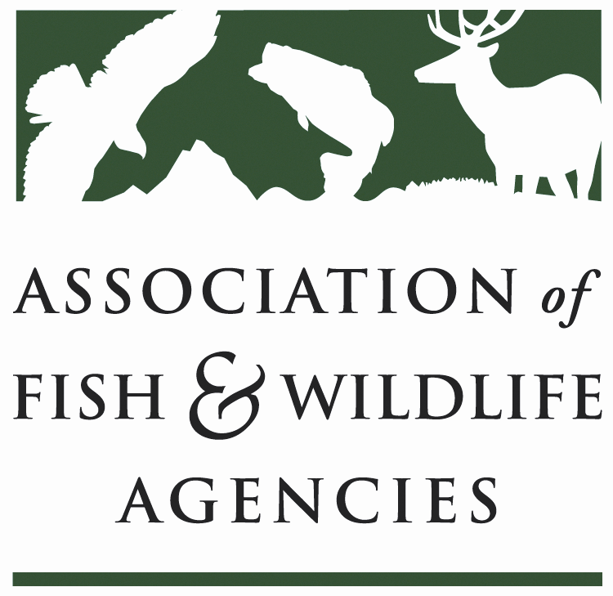

Energy & wildlife policy committee
Chair: Brad Loveless (KS)
Vice-Chair: Bob Sargent (GA)

March 21, 2023
9:00 am - 12:00pm CST

88th North American Wildlife and Natural Resource Conference
Room: See Whova App/ St. Louis, MO

Committee Charge: The energy and wildlife policy committee is focused on understanding and ameliorating the effects of energy development and generation in North America and its impacts on fish and wildlife resources and their landscape habitats at the state, province, territory, region, and international levels.

Agenda

9:00 am Call to Order / Approval of Minutes from September 2022 Meeting
Brad Loveless, KDWPT
- Approved meeting minutes.

9:05 State Roundtable
One representative per state agency highlights a couple of legislative and policy initiatives, issues, or success stories.
- Colorado – Karen Voltura – facing unprecedented push for renewables, over 15GW of wind in review, 2.5m acres; probs 1/3 of that will be developed. There are 800 miles of new transmission on the eastern plains; 125K acres of solar in SW corner not sure how much of that will be built out. Every Lek in the state is under lease or powerlines; some developers are saying they don’t have to mitigate because the transmission line is already impacting; southern CO has deposit of Helium – CO has lots of oil and gas and renewable.
- Jason Hight – FL – regulatory environment is different in Florida and favors smaller sites (<75 MW). If it goes above that it goes through public service review showing grid demand etc., seen 175 GW / 90k acres with over 200 GW, 125K acres in the next 5 years. Service did not list gopher tortoise- trying to increase recipient sites for torts knowing the solar is coming in. wind is not an issue, oil and gas are minor .
- Jennifer Campbell – Missouri – REWI is helping to fund a project to tag eagles to understand flight paths; utility is not part of the windfarm 3-5 year project to get more insight into eagle behavior in the Bluffs area. High Prairie Wind Farm where endangered bats (Indiana bat) exist – phasing in operations, they were not operating during maternity season previously, operating above avoidance this is 6 year HCP to learn more about the risk; in SW part of the state, there are grey bats and unknow how to operate to minimize impact they have some treatment and control turbines; 30 wind projects state wide (except SE), a number are along transmission, about the same solar projects
- Laura Z – Texas – green energy has big target on it during this legislative session – we provide ‘scores’ environmental impact statements now, does that apply to currently operating facilities – have 150 wind farms 200 solar facilities with 18,000 turbines that we would have to retroactively score that would dictate a fee that goes into cleanup, not mitigation. There is both a house and senate bill so likely it will pass. Another bill that we would have to give assessment of impacts. Solar facility in last remaining tall grass prairie and they gave acres to TNC.
  - Brad – in KS, money has been included in decommission, but is that not the case in TX? ; LZ: No. KV: not in Colorado either.
- Scott Whitcomb- Michigan – integrated resource plans 55mi solar, local rules so hard to get any solar permitted, last election had lots of no wind/solar referendums, we try to steer towards Brownfields; inquiry on carbon sequestration we have favorable geology, a lot of that would take place on state land it would take some statutory changes for that to happen.
- Melissa Marinovich – Nebraska – in legislative session currently – in 2017 wind and solar companies had to go to power review board but in 2018, the legislators took that away so renewables could did not need approval; its been hard to get the consultation; currently have a senator pushing to bring back the Power review board; less wind and more solar because of listing on northern long eared bat, we are on the edge of the species range and the species doesn’t really behave the same in our state; not a ton of oil and gas, a very vocal group to are opposed to any new pipeline. Impacts to whooping cranes study for transmission networks through the state, public power district is looking at HCP for cranes.
- Kansas – the easy spots have been taken already, so it’s getting a little more complicated; solar we are playing catch up and learning the ropes; we don’t have much leverage. Brad is trying to get some recommendations to keep solar out of Tall Grass Prairie; FWS is working to be pragmatic with the listing of NLEB; we are removing trees from prairie
- Bob Sargent – Georgia – oil and gas are not issues, there was consideration of a wind project on a barrier island but it didn’t go anywhere; solar continues to be principle issue; GA wildlife federation, GA Power, TNR, GA DNR, GA conservancy, NWTF effort focused on solar siting tool for the SE to make better decisions about where solar is siting and for a better review projects, wanting an automatic review process when GA Power wants to develop. There have been some bad siting decisions that were able to avoid the review process and ended up fragmenting habitat; major issues revolve around Gopher Tort and that occupy a lot of our time, projects are developed before a commitment by land owner to reach out to GA Power and asked to come in to remove all the Tort and its not something we can manage, we can’t relocate 100s of torts and when we relocate, we have to fence them in so they don’t disperse (dispersing torts have high mortality rate). Working to change this; erosion is also an issue, some long leaf pine forests are being lost.
- Jasmine Kleiber – Nevada – public lands development which is subject to NEPA; all projects are generating 10MW are required to submit review and consultation; shift from solar development in southern part of the state to the northern part of the state. We are often cooperating agency with NEPA, we review about 600 projects/year. Lithium mine only one in the state, with 2 more proposed, and all using different extraction techniques. Evaporation ponds are about 50-70 acres in size and migratory birds will land on them.
- Indiana – solar is ramping up, wind is slowing down, we are green energy permitting state we do environmental reviews; carbon storage bill passed so dealing with use of state properties and a new Hydro plant in south bend that we did permitting on which feeds Notre Dame - 7% of power needs.
- **Carbon Sequestration** - touch back on this
- Luke Thompson – Arizona – BLM western energy plan revisit ; we don’t have regulatory nexus in our state so we don’t have a consultation requirement; do have examples of good and bad developers
- Wisconsin – solar is taking off in our state and caught behind on the wildlife BMP

9:50 Wind Wildlife Working Group update (Presentation attached)
Karen Voltura, CO Parks and Wildlife
- Presentation covered history of workgroup and the updated committee charge:
  - Address identified and emerging SFWA concerns and opportunities related to wind siting by:
    - Promoting collaboration among and between state fish and wildlife agencies, federal partners, industry, and conservation organizations;
    - Sharing information on regulatory and non-regulatory mechanisms to support positive siting outcomes; and
    - understanding and advancing the science on wind wildlife interactions and cumulative impacts of wind energy development
- Industry comms folks are engaged, but how do we engage those who are not. That is probably the biggest challenge
  - Brad – what percentage of the industry is a part of ACP? David, ACP: We represent lions share 2/3 to ¾ of the industry but there is a lot of stages to the development, and solar is more diffuse compared to wind which tends to be more consolidated.
  - Brad – the faster we can share siting standards; if we are going to come up with state standards and move it, it will be super valuable. If industry and agency can all agree, that will be super compelling for our state legislatures.
  - Ed Arnett – how much science is enough science before we move on? We don’t need to research stuff together, so how do we start implementing the science that is coming in.

10:05 Solar Wildlife Working Group update (Presentation attached)
Bob Sargent, GA DNR
- Brad: Data sharing came up as an issue at the JTF, and it’s at a very large scale so we need to talk about it!
- Capacity – considered applying for multi-state grant? Wind is looking for other opportunities; this is really important to our future and we NEED the capacity! So, we need to start looking for other opportunities. Brad wants us to really think about what we need and how we could write a grant.

10:20 US Fish and Wildlife Service update (Presentation attached)
Gary Frazer, USFWS
- Presentation covered Mitigation policies including Conservation Banking regulation, BGEPA Proposed rule, MBTA ruling, as well as update on WEG technical addendum
- Brad – with switching administrations, how do you manage? Gary – we have limited resources and focusing on what are the most important things is the biggest challenge, we need to incentivize good practice. This congress has been rolling out congressional review acts. USFWS did not get any additional funding for all this work making thing really challenging.
- Ed Arnett – pleased to see addendum WEG, what is that process? Gary – start with FR notice;
  - What about solar? Discussion next.

10:35 Discussion on Guidelines for mitigating wildlife impacts from large-scale solar (Presentation Attached)
David Murray, ACP, followed by full committee discussion
- Presentation announces that ACP is working with industry members to build a draft of Solar Energy Guidelines for internal discussion and proposed a collaboration with AFWA starting in June with a facilitated discussion following completion of a discussion draft that has sufficient internal consensus on where industry stands on key issues.
- Industry is trying to scope out what it looks like on their side; internal process is just kicking off to come together as an industry, possibly brining in SEIA, to have in-person facilitated group starting end of April to develop straw proposal. ACP is not facilitating, hiring a professional facilitator
- Summer - industry sits down with AFWA and other stakeholders for facilitated meetings; facilitator will help us build consensus, where we are not at consensus, and where the parties are really far apart.
- Laura Z- with this coming from industry, do you think people will sign on?
  - David: ACP intention of putting it all out there, and while we will come with draft concepts, we want to hear and incorporate state feedback; our concern with federal process is the amount of time it will take. WEGs were cumbersome and we didn’t necessarily want to go down that route.
  - Brad: fair comment on timeline, but we can’t emphasize enough getting opinions of folks early. This committee has been talking to ACP for 4 years about this, and the timing happened when Feds announced. We encourage that as opposed to finding the lowest common denominator, to instead be better and more aspirational, we have to do better than the WEGs. Its more important to get us standards that get us where we need to go, as opposed to managing to the lowest denominator.
  - Karen: we don’t really know the outcomes of the WEGs even after 10 years; decisions in the end may still not happen for the agency, it cannot end with the conversations and without the regulatory component, we don’t know how they will work. What are the outcomes of the WEGs – we need to know
    - Brad – we would love to go to state legislators, and say we already have this framework, and can we factor that into the states, and we are looking forward developing something.
  - Gary: SETO and FWS were discussing whether they should invest in doing guidelines, view as ‘altruistic’, we need to do it. Regulatory may happen, but if we can get something that will accomplish and be adopted is key. WEGs through FACA had buy in with both industry and agency.
  - FL Jason - we cannot wait, some of our issues can’t wait. But we want buy in – we have great working relationship with FPL and Nextera but the document we gave them had a BMP for solar and they did not want it because they were concerned it would become a regulatory issue in other states. Please include Florida in these talks. Initiating with ‘where industry stands’, is this the best approach? The more voices and the earlier is the best.
  - Gary: SETO and FWS is trying to figure out how the industry effort will support, preclude, etc with federal effort. How does it align. What is the scope?
    - David: Industry will be strictly wildlife issues
    - Gary F: How inclusive? AFWA is one but are there others.
Brad: no reason to reinvent the wheel
    - Juan: we are in a challenging place of state of the science that clear mitigation action efficacy is not well known. We need to implement a real adaptive approach so we can incorporate new science as they are released. As the states, we lean on you to tell us how to be adaptive, especially as regional priorities change.
  - Brad: renewable development industry, so using the best science we can as it comes up, we need.
- We will be following up with a planning call of how States can effectively converse and respond to ACP and gather up information , so check for that email for planning

10:50 BREAK

11:00 REWI update (Presentation attached)
Christina Marshall, REWI
- Working with an internship program and want to do informal interviews with the students, if anyone wants to participate in the interviews, reach out to Christina
- Painted blade study – looking for additional partners
- REWI research hub – looking for feedback.
- Drafting proceedings of 14th WWRM
- Solar power and wildlife symposium during the week of Nov 13
- 2023 planning a central US Wind Wildlife workshop in person at the NREL

11:15 State Spotlight Presentation - Missouri
Jennifer Campbell, Missouri Department of Conservation

11:30 USGS Update (Presentation attached)
Mona Khalil, USGS

11:45 USGS/AFWA Data Standards in Bat Fatalities at Wind Farm Workshop Report
Bethany Straw, USGS

- Can we do multistate grant for this effort? Need to build capacity, what investment is required for success?

12:00 Wrap-up and Adjourn

