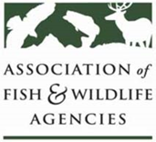

National Grants Committee
____________________________________________________________________________________

Curt Melcher – Chair
Colleen Callahan – Vice Chair

September 19, 2022
10:00 AM – 12 :00 PM (CDT)

Agenda

10:00 AM Call to Order, Introductions, Announcements, and Agenda Review
Curt Melcher, Chair

Approval of the March 2022 Meeting Minutes
Curt Melcher, Chair

Presentation and Discussion of Draft Priority List and Recommendations for 2023 Multistate Conservation Grants
Curt Melcher, Chair / Silvana Yaroschuk, AFWA

WSFR Update
Paul Rauch, WSFR

Further updating Science Priorities for MSCG Program –Russ Mason, AFWA Science, and Research Committee

2022 National Survey Update – Kate Bachtell, NORC

Presentation on Prior Year Grant: 2 presenters

New Business

12:00 Adjourn

