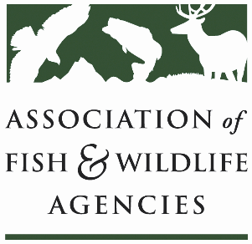

Harvest informaiton program working group
Chair: Karen Waldrop, Ducks Unlimited
Vice-Chair: Josh Avey,

Wednesday, September 8, 2021
4:30-5:30 EST

111th AFWA Annual Meeting

Participants
30

Introductions
Karen Waldrop, Chair, called the meeting to order at 4:33 p.m. and conducted introductions.

Cindy Longmire, DJCase
Cindy Longmire, with DJCase, presented HIP/Harvest Survey results. Findings indicated that:
- Most participants in each focus group did not know the purpose of HIP (66 of 67 participants thought the purpose of HIP was to estimate harvest);
- Most participants thought that HIP survey questions were easy but that it was hard to recall information;
- It was more difficult to predict harvest than to recall harvest totals;
- Participants wanted to know how their participation benefited hunters;
- There was confusion about state and federal agency roles;
- Email is a good way to communicate but it was hard to separate this communication from spam;
- Survey reminders were supported, preferably if participants could customize when reminders were sent;
- There was a sense of responsibility;
- There were concerns about the accuracy of data (date, amount, locations if asked after season)
- There was confusion of how group hunts were reported (double counting);
- There was concern that data would result in reduced bag limits, season restrictions, and LE;
- There were mixed reasons for why inaccurate information was provided; and
- Regarding survey enhancement registration created the most frustration. Data entry was viewed as easy, the submission process was seen as straight forward, but there was a fear that data entry would be time consuming.

There were seven recommendations for improving HIP.
- Increase outreach and education.
- Make survey improvements.
- Explore ways to customize harvest experience.
- Explore smartphone app.
- Explore ways to change survey administration process.
- Make finding information simple.
- Cast a broad net to improve survey response rate.

Phil Seng - All hunters were hunt certified for this project. It would be good to know how many hunters don’t have HIP. Elderly participant and those that are not tech savvy struggle with HIP.

The final report has been completed.

Brad Bortner, WMI
Brad Bortner, WMI, provided an update on the objectives of the HIP pilot project. He will continue to work with states to improve data quality and utility, work with licensing system providers, and work to communicate with agency administrators the need to improve outreach efforts.

HIP pilot map

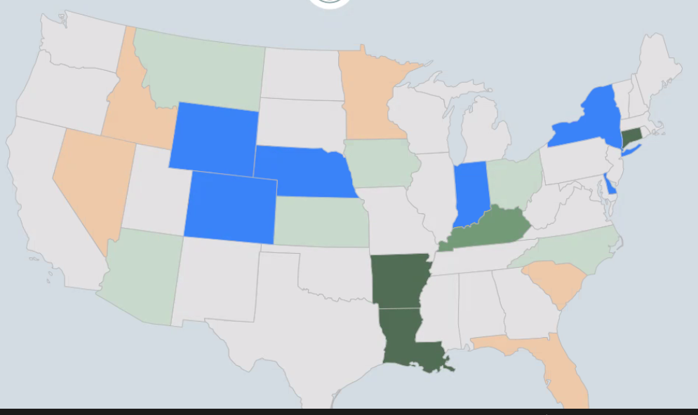

Arkansas HIP Duck Stratum Count

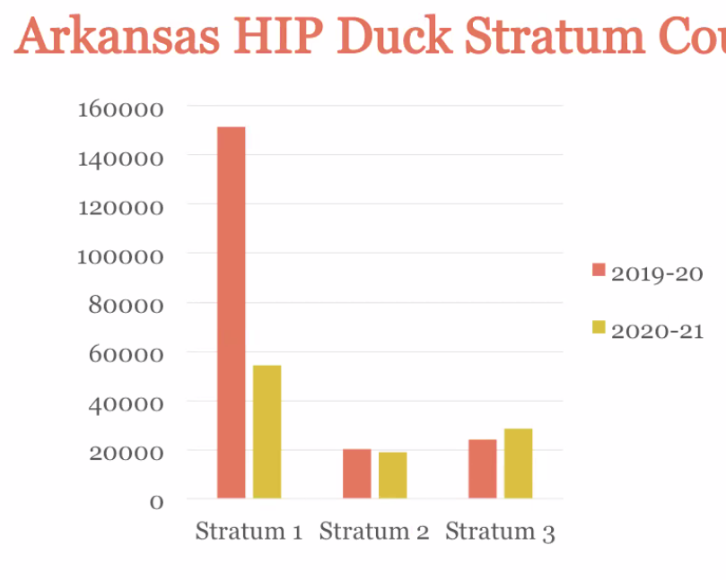

Results
- Arkansas and Louisiana - there has been a modest improvement in the harvest estimates.
- HIP Communications:
- Hunters do not recognize HIP as program between states and the USFWS.
- Hunters do not understand how the questions relate to harvest.
- Hunters do not know how the data is used.
- Most hunters will willingly participate if they understand how they benefit from HIP.
- License vendors, ALS providers and agency personnel do not understand the purpose of HIP.

Ideas to improve the precision and efficiency of HIP include:
- Launching a broad campaign and developing consistent messaging for audiences that include migratory bird hunters, agency staff and license system providers/vendors; and
- Developing objectives, creating a toolkit, recruiting national/regional influencers, conducting outreach to AFWA I&E, LE and licensing committees and briefing ALS developers.

The Flyways support a broad campaign and the Flyway Councils would take action in support of one. Many states have said that they would use a toolkit.

Kathy Fleming, USFWS, HIP Stratification Analysis – Preliminary Results
Data visualizations were produced where hunters can look at data in their state and can filter date by place, date and species to show hunters how data is used.

Some changes are being made to remove barriers from the online survey and improve response rates and the reliability and predictability of stratification is being examined.

There are 880 hunters with surveys for two consecutive years. There is not much predictiveness in harvest from year 1 to year 2.

Questions
Is hunting activity similar over time? There are similar correlations even after 4 years.

Is HIP reliable? In comparing what hunters have done and what they say they will do, answer are not particularly reliable.

Conclusions
Last year’s dove hunting is not the best stratification. About 35% of dove hunters can remember the previous year.

Next Steps
Stratification recommendations will be available in Spring of 2022. There will be an operational online harvest survey in Fall 2022.

There is a need to pursue more formal development of a communication plan and to establish a brand and recommendation.. The USGS will be doing a model-based harvest estimate in Fall 2023.

The meeting adjourned at 5:33 p.m.

