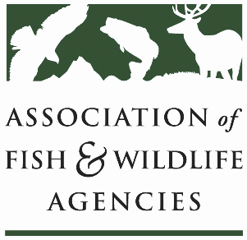

Public Access WOrking Group
Chair: Sal Palazzolo(ID)

Date: Thursday, September 9, 2021
Time: 3:15 – 5:15 pm ET

111th AFWA Annual Meeting
Agenda
3:15 Call to Order, Agenda Review, Minutes
3:20 Review of Survey Results
3:50 State Roundtable
5:15 Adjourn

