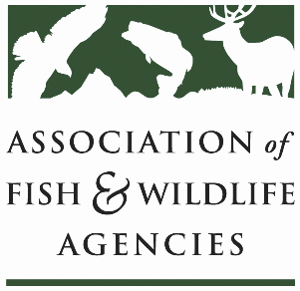

Private Lands WOrking Group
Chair: Ray Aberle (CO)
Vice-Chair: Bill White (MO)

Date: Wednesday, September 8, 2021
Time: 10:30 – 12:30 pm ET

111th AFWA Annual Meeting
Agenda
10:30 Call to Order, Agenda Review, Minutes Ray Aberle (CO); Bill White (MO)
10:40 Evolution of the South Dakota Game, Fish and Parks Landowner Program – Mark Norton (SD)
11:00 Review of Survey Results Bill White (MO); All
- State of the States’ Private Lands Technical Assistance
- How can AFWA help states expand their efforts?
11:30 NABCI Private Lands Forum Todd Fearer (AMJV/NABCI)

11:45 Review of Guidance for Private Lands Biologists Ray Aberle (CO); All
- Hiring Processes
- Key Player Partnership Development
- Onboarding and Training
- Sourcing Hires
- Reporting and Messaging to Support these Positions

12:10 Private Lands WG Next Steps Ray Aberle (CO); Bill White (MO); All
12:30 Adjourn Ray Aberle (CO); Bill White (MO)

