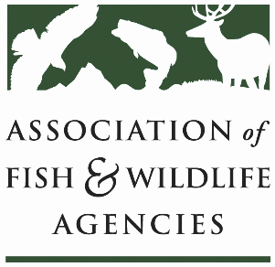

Farm Bill Easements WOrking Group
Co-Chair: David Breithaupt (LA)
Co-Chair: Vacant

Date: Thursday, September 9, 2021
Time: 1:00 – 3:00 pm ET

111th AFWA Annual Meeting
Agenda
1:00 Call to Order, Agenda Review, Minutes
1:10 NRCS Update
- ALE
- WRE
2:00 State Roundtable
3:00 Adjourn

