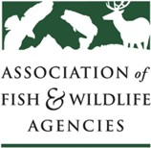
LEAD AND FISH AND WILDLIFE HEALTH WORKING GROUP
Chair: Stafford Lehr (CA)

Thursday, September 10th, 2020
3:00 PM – 4:00 PM

AFWA Annual Meeting

Agenda

- Welcome & Introductions
Stafford Lehr (CA)

- State Fish and Wildlife Agency updates
State fish and wildlife agency staff

- Federal Agency updates
Federal agency staff

- Industry updates
Industry representatives

- Collaborative Approaches to Minimize Lead Exposure
Chris Parish, The Peregrine Fund
Leland Brown, Oregon Zoo

- Update on white paper on vultures and lead
Jonathan Mawdsley, AFWA

- General Information-sharing
All

