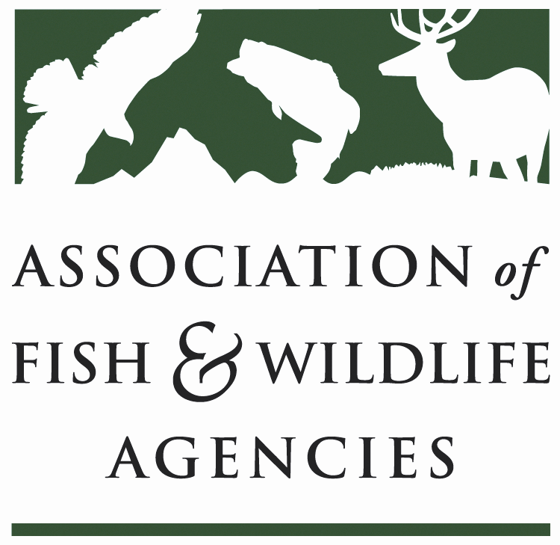
Science & Research Committee
Chair: Russ Mason (MI)
Vice-Chair: Jason Sumners (MO)
Staff: Jonathan Mawdsley (AFWA)
2020 Association of Fish and Wildlife Agencies Annual Meeting
Thursday September 10, 2020
9:00 AM – 11:00 AM
Agenda

- Overview of the Science and Landscape Priorities document (Jonathan Mawdsley);
- Discussion of the new roles and responsibilities of the AFWA Science and Research Committee (Russ Mason and Jonathan Mawdsley)
- Identify and codify Science and Research Committee sub-groups to address the new roles and responsibilities, together with ‘owners’ or sub-chairs for each of the sub-groups;
  - Federal Partners
  - Cooperative Research Units and University partners (e.g., PERM faculty at MSU)
  - State Agencies (those that have research internal capacities)
  - AFWA Committees
  - Regional Associations (and their science partnerships)
  - NGOs (e.g., TWS, AFS)
- Consideration and approval of a short statement to the AFWA Executive Committee supporting the recommendations of the Science and Landscape Priorities document;
- Call for a Science and Research Committee meeting in 6-8 weeks among the sub-group chairs to talk about plans, opportunities, challenges.

- Adjourn

