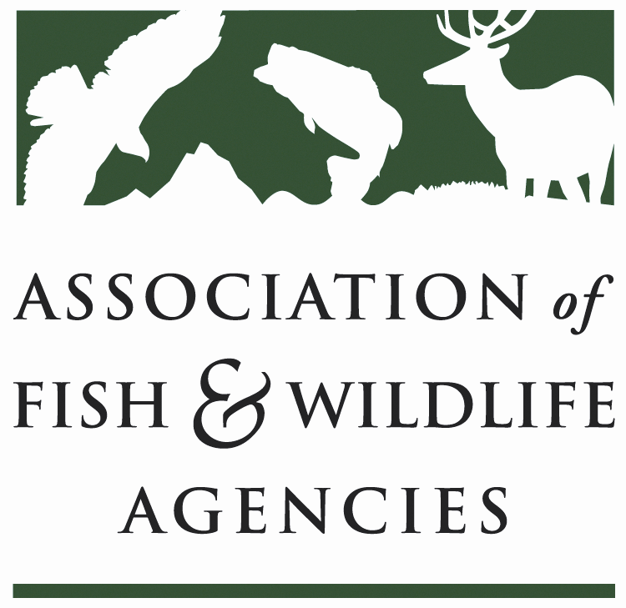

fish and wildlife trust funds Committee
Chair: Bryan Burhans (PA)
Vice-Chair: Mike Fowlks (UT)

March 13th, 2020
9:00AM – 12:00 PM
North American Conference
Omaha, NE

Bryan Burhans chaired the meeting. 21 participants in attendance, including 8 current Committee members.

Scheduled Discussion Items

- Call to Order, Introductions, Announcements, and Agenda Review – Bryan Burhans

The meeting was called to order at 9:00AM. The Committee Chair, Bryan Burhans welcomed all the attendees and asked the participants to introduce themselves.

- Approval of the September 2019 Meeting Minutes

The meeting minutes from September 2019 were approved.

- 2022 National Survey and States buy in options – Mike Dennis, N.O.R.C

N.O.R.C will be conducting the 2022 National Survey. The most part of presentation was about the options for the states to buy in.
NORC at the University of Chicago is an objective, non-partisan research institution that delivers reliable data and rigorous analysis to guide critical programmatic, business, and policy decisions. Majority of work we do is federally funded and serves public purpose.
What will 2022 National Survey look like?
- National level estimates – involves the most rigorous sample of households that you can collect at this point of time
AmeriSpeak Panel (6,000 screener cases)
Address-based sample with adaptive survey design (~30,000 total cases)
- State level estimates
Supplement national sample with state-level nonprobability sample (~20,000 total cases) using TrueNorth Calibration
Included for coastal states for freshwater/saltwater counts
Option for states to buy-in and/or purchase additional estimates

Probability sample:
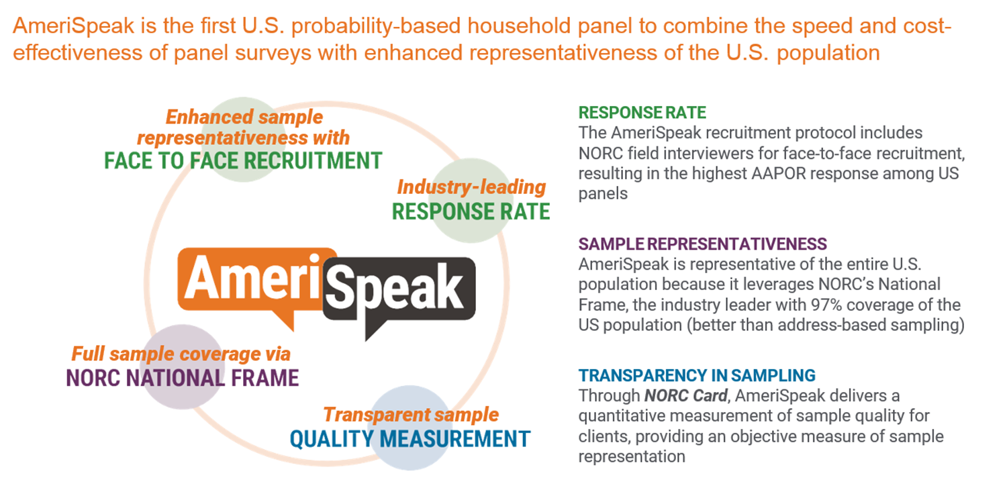
NonProbability Sample
- Used only for state samples (coastal states)
- Required sample size for a state based on:
CV requirement for the state
National probability sample size for the state
Minimum threshold of probability sample completes
- Use of online nonprobability panels
- Demographic and geographic targets to partially address non-coverage and non-response
- Weighted using TrueNorth Calibration
This samples have problems and that’s why we bring TrueNorth samples.

Questionnaire content

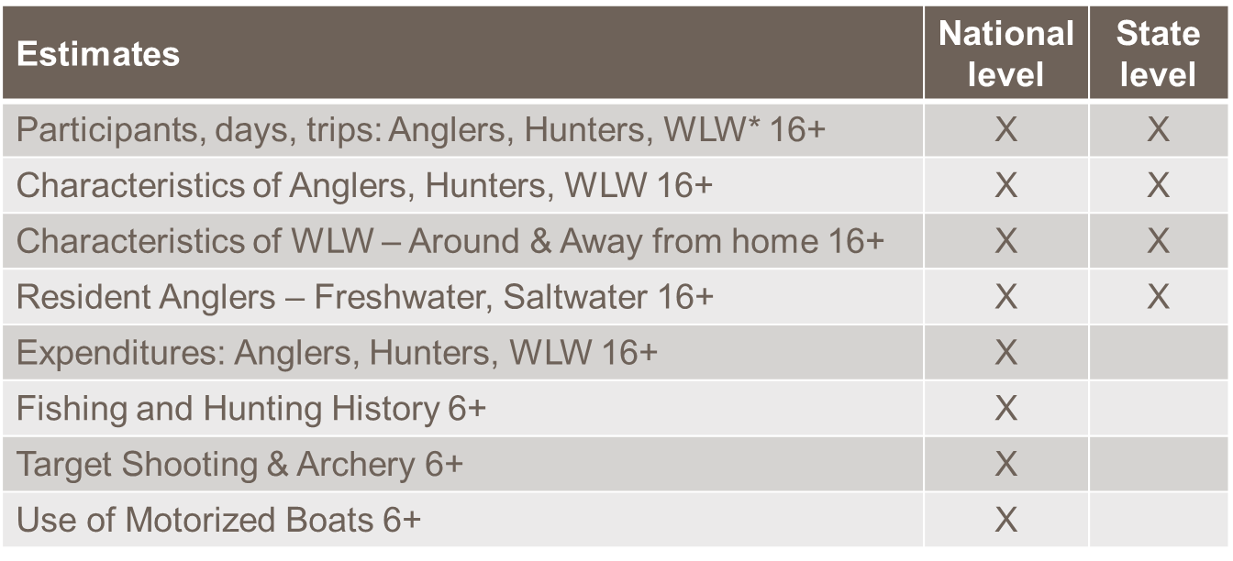

Deliverables
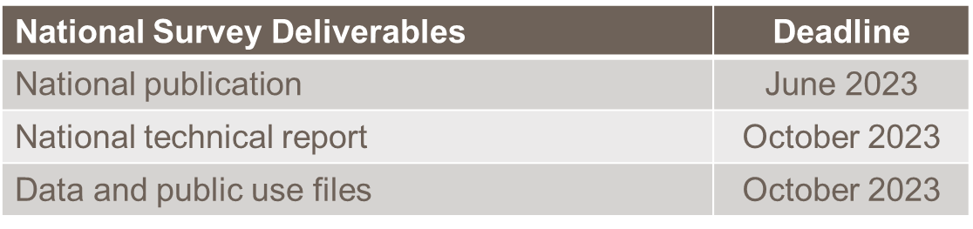
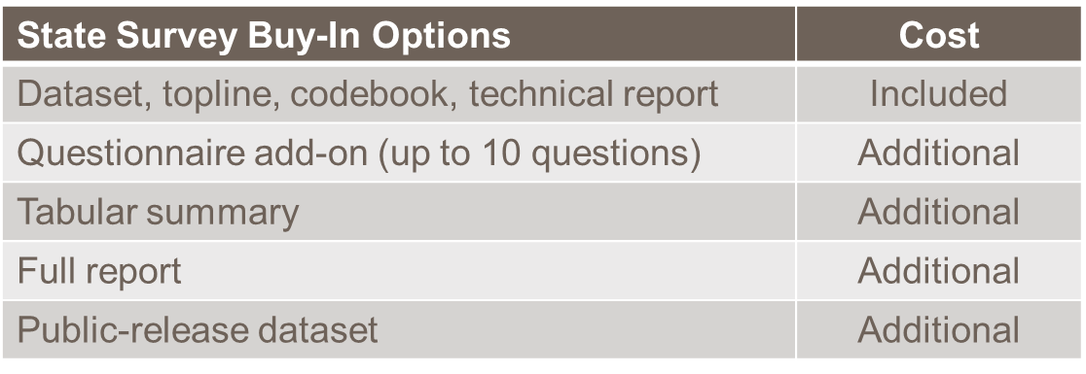

Website for state buy-in

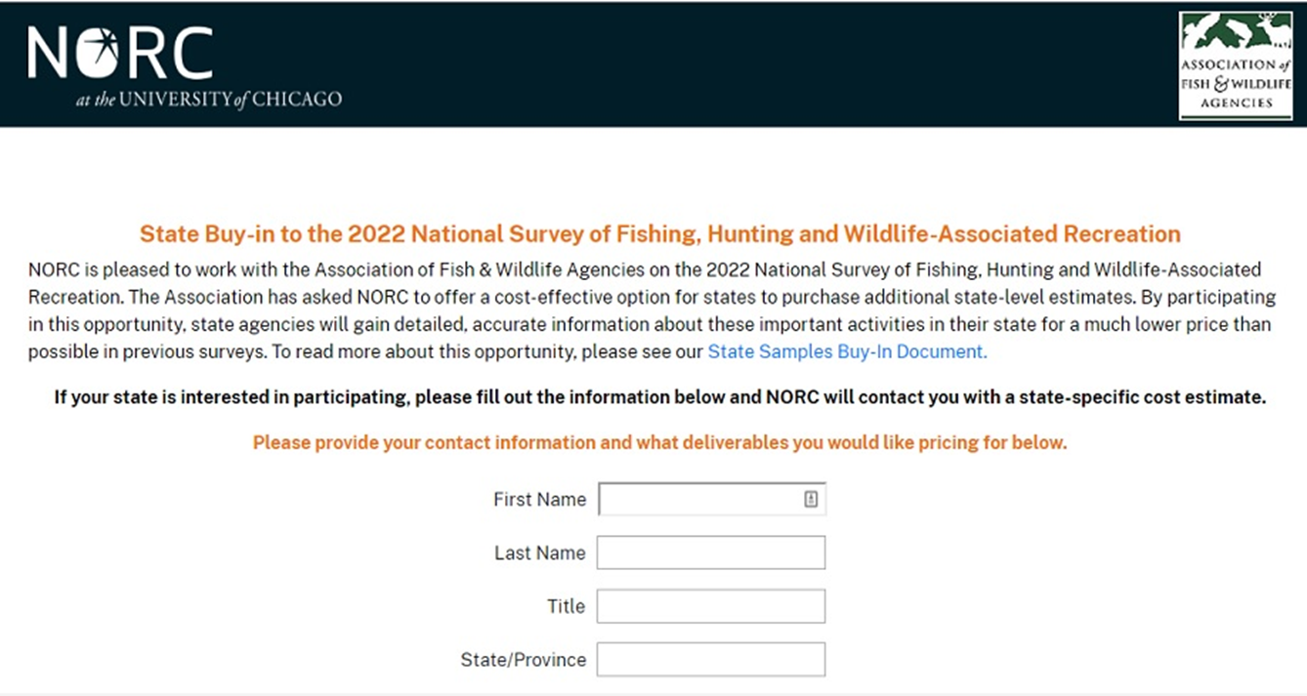

Question: Can the states apply through the MultiState Conservation Grant Program to cover state level data?
MultiState Conservation Grant Program funds grants that benefit multi states and these requests would be for individual states. The money could come out of (individual) state grants.

- Federal excise tax slippage through online marketplace facilitators – Dan Forster, ATA

This is an update on excise tax slippage issue. The excise tax can be very complicated. The issue is slippage of excise taxes through the online marketplace facilitators. For US based manufacturers there are a lot of regulations to follow, but if you are a non-US based manufacturer selling directly to the consumer, the consumer is considered the importer and therefore they are responsible to pay the tax. They don’t know there is a tax, they don’t know how to pay it and who know if they knew they would pay it or not. One of the challenges we have is to try and identify how big the problem is. We are using Multistate Conservation Grant Program funding through WMI to contract someone and trying to figure this out. There are several internet marketplaces that facilitate archery equipment sales. And we are just trying to make this fair. We have been working through AFWA Trust Fund Committee and talked to IRS, engaged Amazon, and we have interested parties at the Services to try to find a solution. This issue is not going away any time soon.

- Wildlife and Sport Fish Restoration Update – Paul Rauch/Bob Curry, WSFR

- Program Administration
  - Assigned WSFR AD responsibility for Program: Administration, Management, Oversight
  - Set funding caps for administration
  - Requires biennial administrative audits
- Shared Vision for Program Administration
Why?
Improvement Act requirements are best met when FWS, States, and Industry are on the same page; Provides WSFR AD a roadmap for collaboratively meeting statutory responsibilities; States and Industry have a “standard of service” expectation for how the program will be administered

- A Brief History:
2016 TFC asks FACWG to update State Needs Document
2017 TFC vets and approves document
2017 WSFR completes PMA
March 2018 TFC charters Shared Vision Workgroup
September 2018 TFC Endorses and AFWA Membership approves Shared Vision
2019 WSFR conducts Funding Needs Analysis
2019 WSFR develops Shared Vision Implementation Strategy

Principles:
- Promote efficient grant review
- Standardize processes
- Prioritize program integrity/accountability
- Stakeholder visibility/input
- Enhance strategic communication

FWS Commitments: Take actions consistent with principles; Transparent progress reporting; Seek stakeholder input; Honor established collaboration tools: Trust Funds Committee, Joint Task Force, Federal Aid Coordinators WG, TRACS WG

FY 2020 Actions

- Promote efficient grant review
Initiate development of a National Training (SOP) Manual for WSFR Grant Management Workflow
Increase regional grant/fiscal staff (contingent on admin funding increase)
Enhance environmental compliance streamlining tools
- Standardize processes
  - Implement GrantSolutions
  - Standardize when, why, and how of conditional grant approvals
  - Develop BMP for performance report approval (minimize subjectivity)
Discussions:
States are concerned with the shutdown. The states can’t get grants approved for a 10-week period. We don’t have any answers from the regional offices and have to wait till next year. So, we’re concerned what the end result will be to the conservation on the ground.
We have heard from the Chiefs that if we don’t have a letter saying the grant is awarded when we start our fiscal year on July 1, we can not set up state account to charge things to.

- Prioritize program integrity/accountability
  - Implement TRACS
  - Increase training (contingent on admin funding increase)
  - Implement PRDJ Accountability Initiative
  - Consistent NOFO compliance
  - Enhance recipient risk assessments
  - Increase audit support staff
- Ensure stakeholder visibility/input
  - Honor existing venues (TFC, JTF, FACWG, TWG)
  - Institutionalize communication protocol into all significant decision making
  - Report administrative expense summary at least annually
- Enhance strategic communications
  - Complete Strategic Communications Plan
  - Expand Partner with a Payer
  - Develop TRACS Conservation Viewer requirements
Shared Vision –
Ask of States for FY 2020
  - TRACS: Translate, Test, and Train
  - GrantSolutions: Train and Use
  - PRDJ Accountability Initiative: Support
  - Conservation Viewer: Engage
  - Partner with a Payer: Participate
  - Process Standardization: Compromise
Ask of Industry for FY 2020
- Conservation Viewer: Engage, Patience
- Partner with a Payer: Expand
- Industry/Agency Summit: Participate

WSFR Administration

  - Funding

WR saw 10.65% decrease from FY19, and with matching funds, WR = $752.2M
SFR saw 0.18% decrease from FY19, and with match, SFR = $462.1M almost $half billion
FY 19 SFR apportionment was amended to correct errors made in FY 2017, 2018 and 2019. An error in the SFR apportionment calculation table resulted in a reduced overall apportionment to states of $3,000,000 per year for Fiscal Years 2017, 2018 and 2019.
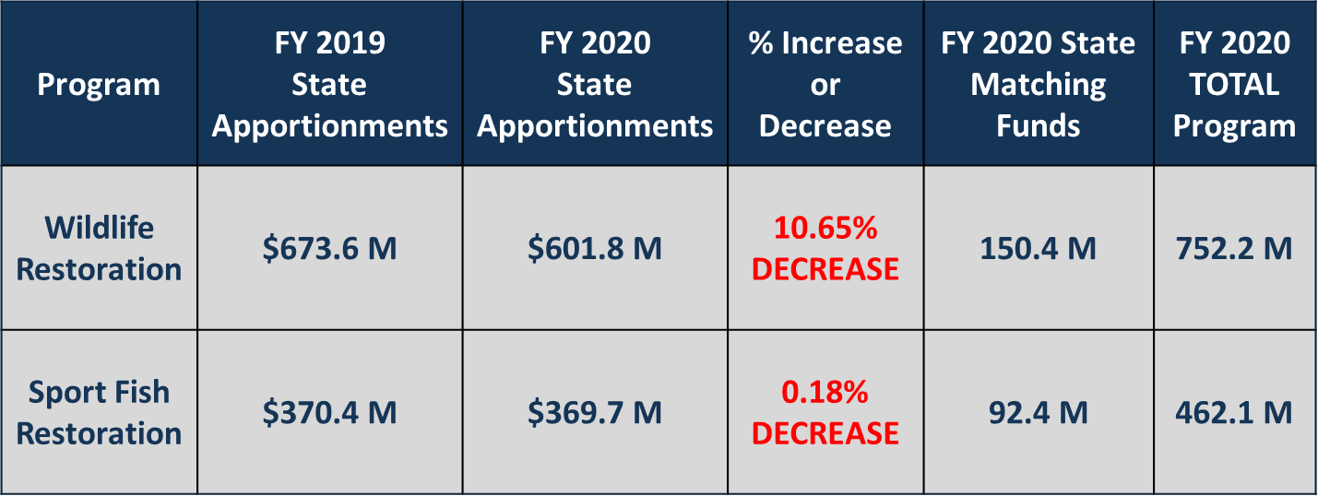

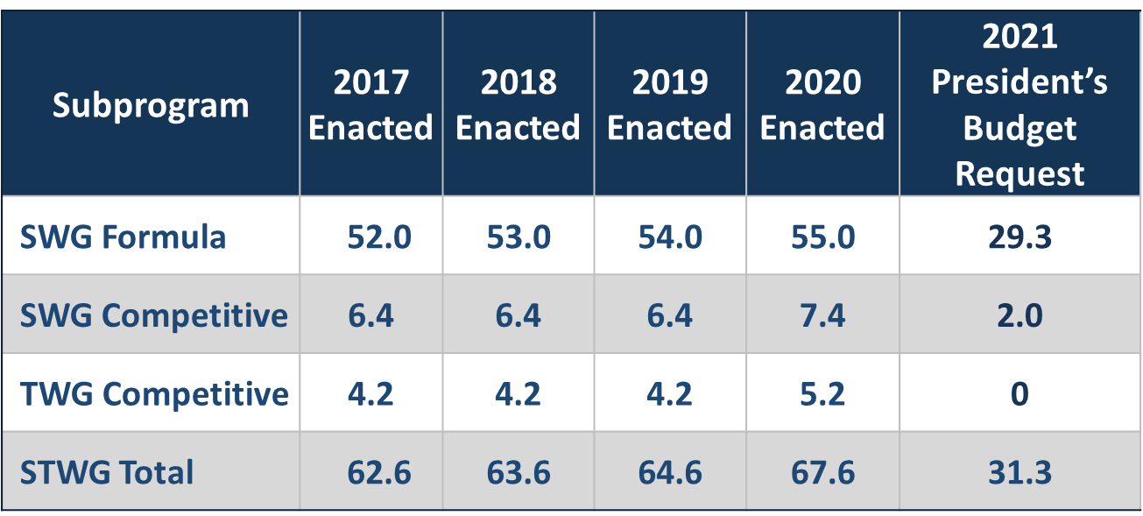

  - Policy

Lands Chapters - Adjusted to accommodate Financial Assistance Interior Regulation (FAIR). PUBLISHED 12/4/2019
50 CFR 80 - Updated regulation to include, among other changes, the new license certification standard. PUBLISHED 8/27/2019

  - Modernizing the PR Fund for Tomorrow’s Needs Act

The Act Adds:
Purpose: Provide financial and technical assistance for the promotion of hunting and recreational shooting;
Definition: hunter recruitment and recreational shooter recruitment, which includes:
    - outreach and communication,
    - education (targeted to both participants and the public),
    - mentoring, field demonstrations, and
    - access;
Modern Multistate Grants:
    - Up to $5M annually
    - Hunter recruitment and recreational shooter recruitment grants that promote a national hunting and shooting sports recruitment program, including related communications and outreach activities.
    - Must conform to the historic eligibility criteria benefiting

  - Target Practice & Marksmanship Training Support Act

The Act also provides:
Advantages for a State engaging in activities for:
1) acquiring land for,
2) expanding, or
3) constructing public target ranges.
May allocate up to 10 % of apportioned WR funds to supplement Enhanced Hunter Education (EHE) funds for these activities.
Allocated WR funds + Basic Hunter Education (BHE) + EHE funds allocated for these activities are available for 5 years with up to 90% Federal cost share.

  - National Survey

2016 Survey Addenda now available:
- Recruitment and Retention of Hunters and Anglers: 2000-2015
- Wildlife Watching in the U.S.: The Economic Impacts on the National Economy in 2016
- Birding in the U.S.
Under development:
- Trends in Wildlife Watching 1991 to 2016

- Legislative Updates – Jen Mock Schaeffer, AFWA

RAWA Momentum Growing: The Recovering America’s Wildlife Act (RAWA, H.R.3742) continues to gain momentum in the House with 178 bipartisan cosponsors. The next step is passage on the House floor, and there are no firm commitments yet from House leadership on timing of that floor action, but we anticipate movement this spring.
We are also working on the Congressional Research Service Memo that came out with one of our Congressional Offices in the House and we are looking at the numbers and figuring out how we can use a powerful tool to say if you did nothing, that’s what expenses will look like to list 12,000 SGNs down the road based on current data.
America’s Conservation Enhancement Act H.R 925 bill includes several legislative priorities for the Association including reauthorization provisions for the North American Wetlands Conservation Act (NAWCA), the National Fish and Wildlife Foundation, and Chesapeake Bay conservation and restoration efforts. It also codifies the National Fish Habitat Partnerships and establishes a US Fish and Wildlife Service (FWS) Chronic Wasting Disease (CWD) task force, which would be responsible for ensuring completion of many of the components found in the CWD Transmission Study in Cervidae Act (S.382, H.R.837), protects states’ authority to regulate sport fishing tackle in the environment as it relates to the Toxic Substances Control Act, and more beneficial provisions. The unanimous consent vote by the Senate for this bi-partisan package was the product of bipartisan negotiations, and it has been made clear that any changes, such as removal of the sport fishing tackle, will likely prevent this legislation from passing the Senate again.
Please contact your U.S. Representatives and ask them to: 1) support passage of this bill as reported by the Senate; 2) convey to House leadership the importance that H.R. 925 be passed immediately and without change; and 3) how critical these programs are for state-led and community-based conservation efforts in your state.
Wallop-Breaux Reauthorization Awaits Transportation Package: It has to be reauthorized with the Transportation Bill every five years. The current Transportation Bill expires September 30th 2020. On October 23, Reps. Cunningham (D-SC) and Graves (R-LA) introduced the bipartisan Sport Fish Restoration and Boating Safety Act of 2019 (H.R. 4828), which would reauthorize and extend the Sport Fish Restoration and Boating Safety Trust Fund into 2024.
We included recommendation to increase funds for Wildlife and Sport Fish Restoration (WSFR) Programs administration commensurate to meet states’ grant administration and training needs; eliminate the full-time staff limitations in order to capitalize on WSFR’s new organizational efficiencies; require a study on boat recycling opportunities; and require a Government Accountability Office report examining non-motorized vessel uses and impacts to motorized access facilities, waterway access conflicts between user groups, and the use of Sport Fish Restoration Program funds for creating non-motorized waterway access points.
Land and Water Conservation Fund and Restore Our Parks Act Moving Quickly in Senate: The two bills will likely be merged before for they go to the Senate floor for vote immediately following the comprehensive energy package. As introduced, the Senate’s Restore Our Parks Act only provides funding for the National Park Service while the House version, H.R.1225, also includes funding for USFS roads, FWS refuges, Bureau of Land Management, and Bureau of Indian Affairs Education. The conservation community prefers the House version, and after much work by key conservation groups over the weekend of March 8, it appears a new deal negotiated and before going to the floor S.500 will include provisions that are more similar to the House.
Comprehensive Energy Reform Package in Senate: Chairman Murkowski (R-AK) and Ranking Member Manchin (D-WV) of the Senate Committee on Energy and Natural Resources unveiled the American Energy Innovation Act (S.2657) on February 27, with plans to introduce the bill as an amendment in the nature of a substitute. This bipartisan package contains more than 50 pieces of legislation previously advanced in committee, focusing efforts on making energy cleaner and more affordable as well as strengthening security. Consensus legislation in the bill covers efficiency, renewables, storage, carbon capture, advanced nuclear technologies, and more. Previous concerns by the Association involved the potential for hydropower provisions to preempt state authority on permitting species recommendations and considerations, and we are going through the language to assess details. The bill was expected to move the week of March 9 as it is a priority for Majority Leader McConnell (R-KY) but it did not.
The Congress canceled the recess for next week so they can take on Coronavirus legislation package. They have shut the door to the public and everything by phone now. So, we have canceled a lot of meetings that were already planned.
We are trying to get 60 cosponsors on the bill before it goes to the floor. We are at 59 right now.
Proposed Legislation to Affect Trust Fund Receipts: While the ABA has formed consensus on Wallop-Breaux reauthorization, some industry interests are actively pursuing modification to the Sport Fish and Boating Trust Fund structure. The Fishing Equipment Tax Relief Act of 2019, H.R.3556, would lower the tax rate on portable electronically-aerated bait containers from 10% to 3%. The Association’s position traditionally has been that any proposed reduction in excise tax for a product should provide an alternative method to wholly preserve the financial integrity of the Trust Fund. The differential to the fund that would result from this change is estimated to be about $1 million.

A summary of all legislative updates was distributed to the participants.

• WSFR FA Joint Task Force Update- Paul Rauch, WSFR

Paul gave an update on JTF Action Items.
One of the discussions we had was to better define State Fish and Wildlife Agencies and what that means. JTF and AFWA Executive Committee came to same conclusion that there are too many different competing interests and too many different views of it to get to a consistent resolution so we will leave things the way they are.
We also had some discussions about the relationship between the Federal Aid Coordinators Group and JTF on what issues will be vetted and addressed at the JTF. We will do an annual call memorandum to solicit issues and once we get issues in to feed them to Federal Aid Coordinators to veto those send the recommendations back to the JTF.
We also discussed the policy development. We are working on a new approach for policy development protocol. We will put together a group to look at that.
Also, there is an idea of looking at a broader vison for WSFR whether or not the way we are doing business, not the administration of the program but the program as a whole, is meeting the needs of modern conservation world. This has gotten any traction, but we might talk about in the future meetings.
We also had an action item on the need of developing some guidance for reporting.
We had an action items for the Lands and Facilities Matrix to move forward with Fatal Flaw review incorporated into beta testing.
Our goal is to have a draft agenda out to the JTF member 60 days before the meeting.
Final action item was that we recognized Kelly Hepler for his long membership in JTF as co-chair and we plan to celebrate properly hopefully during AFWA annual meeting.

Tammy Brooks, Federal Aid Coordinators Working Group requested that: Fish and Wildlife Trust Fund Committee approve the Bylaws for Federal Aid Coordinator Working Group which include update on proposed process for the review of issues presented to the JTF.

Trust Fund Committee members approved the FAC ByLaws.

Action Items:

- Fish and Wildlife Trust Fund Committee approve the Bylaws for Federal Aid Coordinator Working Group which include update on proposed process for the review of issues presented to the JTF.

- Wrap Up/Adjourn

