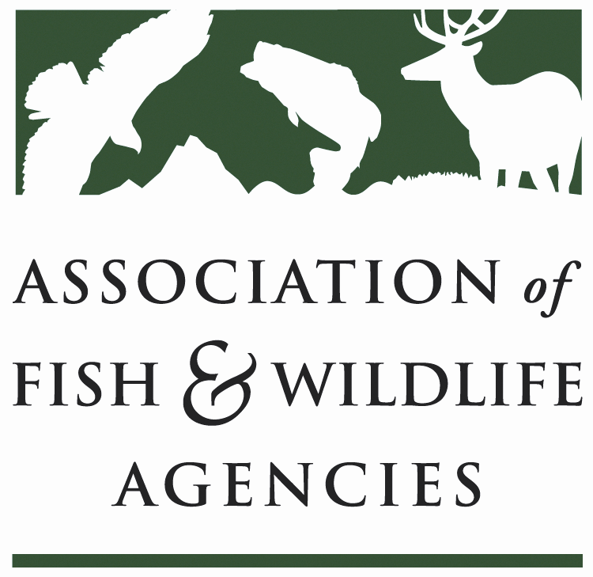

110th Association of Fish and Wildlife Agencies Annual Conference*
https://www.afwaannualmeeting.org/afwa-annual-meeting.html

Sustainable Use of Wildlife Committee
Thursday, September 10th
9:00 a.m. – 12:00 p.m.
Committee Charge:
Advocate the North American Model of Fish and Wildlife Conservation and promote the sustainable use of fish and wildlife resources at the international level.

Chair: Terry Steinwand Vice-Chair: Dave Kay

Subcommittees and Working Groups:
U.S. Furbearer Conservation Technical Working Group

Agenda
- Agenda review, adjustments, and opening comments (Terry Steinwand, Dave Kay)
- Approval of Minutes from the previous meeting (Steinwand)
- Sustainable Use of Wildlife – Principles and Perception from other Nations (Don MacLauchlan)
- MSCG update – Public Understanding \ Reflections on the “take of wildlife” – Preliminary information from current Multi-state Conservation Grant. (Zach Lowe)
- MSCG update – Natural Resource Agency Understanding \ Support for utilization of wildlife resources. (Rachel Menale)
- Sustainable Use of Wildlife Principles – Communication and Understanding – Future Relevance (Tom Decker)
- Congressional Sportsman’s Foundation – Trophy Hunting Legislation (TBD)
- Update on Current and Competitive Multi-state Conservation Grants (Tom Decker, Zach Lowe, Bryant White)
- Sportsmen’s Alliance (Bruce Tague)
- Safari Club International (Jeremy Clare)
- Conservation Leaders for Tomorrow Program (Zach Lowe, Dave Windsor)
- Joint Management Committee Meeting for the Agreement on International Humane Trapping Standards (AIHTS) 2020 (Dave Kay, Tom Deliberto)
- AIHTS Implementation and Trap Testing in Canada (Dave Kay)
- Best Management Practices for Trapping: Progress, Plans and Outreach (Bryant White)
- Other topics potentially affecting Sustainable Wildlife Use (Terry Steinwand)

