MINUTES
Joint Federal-State Task Force on Federal Assistance Policy
Custer State Park, 13329 U.S. 16A, Custer, SD 57730
April 24-25, 2017
_____________________________________________________________________________________
JTF Co-chairs: Kelly Hepler (SDFG), Paul Rauch (USFWS)
JTF Members: Bob Curry, Tom Busiahn, Lisa Van Alstyne, Mike Piccirilli, Clint Riley, Benjamin Tuggle (absent), Lisa Evans, Glenn Normandeau (absent), Jim Douglas (absent), Jack Buckley, Ed Carter and Larry Voyles
Legal Counsel: Carol Bambery, Larry Mellinger
Guests: John Frampton (CAHSS), Jon Gassett (WMI), Lane Kisonak (AFWA)
Contact: Silvana Yaroschuk (AFWA)
USFWS Contact: Peter Barlow, Fish and Wildlife Administrator, JTF Coordinator
___________________________________________________________________________________
- Welcome and Introductory Remarks – Helper/Rauch

Kelly invited all participants to visit the Custer State Park Information Center, which was completed last year with donated money ($4M).

Kelly briefed the group on a SD issue concerning recreational use of water (about 500,000 acres) over private land. This link provides background on the issue as well the ruling. This PowerPoint offers more information.

- Agenda Repairs – Paul will talk about the $100K+ grants.

- Status of Spring JTF Action Items – Bob Curry

  - Audit Findings – This is in the agenda and we will talk about it.
  - 5-year report Indicators - All 6 items were accomplished.
  - TRACS Working Group – All 3 items were accomplished.
  - Pen Raised Birds – Lisa will have a briefing in this meeting.
  - Next JTF meeting
  - Draft MOU – TRACS – There will be an update on the MOU later in meeting.
  - License Certification – It will be discussed later.
  - Decision Points and Action Items – Silvana will distribute these to AFWA and State Directors, and WSFR will send them to the Chiefs.
  - JTF Support – Pete Barlow is replacing Joyce.
  - TRACS Assessment Report – Done.
- AFWA Update – Carol Bambery

This discussion focused on how we will implement directives required for the Blue Ribbon Panel legislation (H.R. 5650). AFWA and WSFR plan to move forward together on the proposed changes. Performance measures for Tracking and Reporting Actions for the Conservation of Species (TRACS) and State Wildlife Grants (SWG) are on the agenda.

At the Industry Summit, attendees responded to a proposal to withhold 10% of DJ funds for use in marketing activities. Attendees agreed that State directors would not support the idea. Industries need to see stronger evidence of recruitment, retention, and reactivation (R3) efforts. Industry partners feel that they are not being made aware of State fish and wildlife agencies’ efforts to increase R3.

Another issue addressed at the Summit was determining what additional items could be taxed if 10% is spent on R3. Without a current lump sum for R3 financial support—which the 10% proposal would accommodate—we have various methods of achieving R3 around the country. The Council to Advance Hunting and Shooting Sports (CAHSS) is considering development of a National plan to integrate all 50 State agencies. But CAHSS does not have much money to work with and thus must leverage resources from their State partners to make their work more effective. In addition to the CAHSS model, the RBFF model allocates $15 million to R3 efforts, of which$12 million is spent on projects involving more than one State. These efforts have led to increased organizing among States on the Wildlife Restoration side of funding, but collaboration for R3 on fishing and boating does not appear to be increasing. Some industry CEOs said that their excise payments into this program exceed financial benefits they are receiving.

Finally, the issue of aerated buckets arose during the Trust Fund Collection Working Group meeting. An ASA representative mentioned legislation that would reduce the excise tax on aerated buckets from 10% to 3%. This bill has been introduced but AFWA does not support it. AFWA policy would consider an excise tax reduction in exchange for increased emphasis on archery education.

- WSFR Update – Paul Rauch

  - When the new administration took over, two actions affected the Federal work force:
    - Hiring freeze put in place following inauguration, and
    - The new Executive Order on reorganization.

On April 12, 2017, OMB issued a 14-page memorandum reducing budgets for training, conferences, day-to-day operations and hiring. By June 30, Federal agencies were to have a reorganization plan aligning with the President’s 2018 budget. In addition, OMB was to meet in July with heads of CFO agencies (including DOI) to go through high-level proposals and identify specific initiatives they want implemented immediately. By the end of September, we must finalize our plan.
Action Item 1: Distribute the 14-page OMB issued Memo to State Directors and FAC (M-17-22) – Silvana Yaroschuk by May 1, 2017

  - On April 19, 2017, a secretarial memorandum was released, titled: “Managing Grants, Cooperative Agreements and Other Significant Decisions.” The memo focused on review of grants over $100K. FWS was charged with devising a process to deal with this order and we have a process laid out.

As with other administrations, this one is trying to figure out what is going on with Federal grants and cooperative agreements before signing them. The administration has not made the distinction between the mandatory and discretionary awards, which adds time to the award process by increasing the volume of awards that are re-evaluated. Soon they will realize that most WSFR grants are mandatory and there are not many reasons to evaluate them. We may see some loosening of rules and WSFR hopes to develop a streamlined evaluation process. The main concern right now is that the Secretary’s Office is understaffed.

JTF members were concerned about timing relevant to the States’ fiscal years. Virginia, for example, was trying to complete a $10m acquisition. This administration may not be aware of the States’ needs or the how sensitive the timing is for select grants. Most DOI staff understand the award process but it is harder to convince higher-level political staff. Political groups may not have a good understanding of the WSFR-State relationship and Federal funding.

The best resolution would be to inform politicians about the funding cycle and differences between mandatory and discretionary funding. If the Secretary engages, at least there is groundwork for some understanding among his political appointees.

There are concerns over the concepts of block grants and whether the Federal government is really shrinking or Federal responsibilities are instead shifted to the States. Some within the administration are looking critically at reducing not only Federal block grants but also State grants.

If the JTF plans to address the issue, a governor or senator needs to talk straight to the Secretary and explain how this will interfere with the States and whether it will discourage or disadvantage shooters and anglers.

AFWA Action Item 1 - AFWA will send a letter to the Secretary on behalf of the States on the impacts that the $100,000+ grant review process will have on states – Carol Bambery

- Strategic Communications Plan – Paul Rauch

On the Federal side, the WSFR program is trying to better define communication with partners and make sure that they are working well with the States. WSFR leadership is putting together a small team to work on this issue. The plan is to remain engaged with States and other partners. This is not an effort to drive the WSFR message but rather to define its role within the bigger picture. Also, WSFR must determine what they are trying to get out of the 5-year report to make sure that they receive some return on investment for the small amount of funds they are spending on communications at Federal level. WSFR is attempting to issue a small contract for support on their communication strategy and put together an internal team. As WSFR goes forward, they will share progress with the JTF.

- Update on Industry Business Summit – Jon Gassett

The focus of this year’s summit was industry assistance with R3 efforts. Discussions included how to increase the number of customers for States and industry. The issue is not that Industry doesn’t get what the States are doing for R3; rather, it is how well the discussions are handled. This year’s grants are focused on 3-4 criteria rather than 7-8 we used a few years ago. One of the criteria is to help CAHSS and RBFF step down national plans to the local level.

Mitch King, a contractor with WMI, works on excise tax issues including products that were moved back to the joint treasury. According to WMI, States and industry partners feel that there must be some resolution/clarification on this issue to provide equitability and ensure that the excise tax system does not disenfranchise industries or make manufacturers less competitive.
WMI developed a list of expectations that states have for industry, as well as suggestions from industry partners to government agencies. WMI is revising the list and will circulate it back to states and partners for review. We also discussed how we can measure success, how we implement R3, and how we can be better partners to ensure the program is the best it can be.
As per the Trust Fund Committee’s request that the Service give a presentation on TRACS and the 5-year report, Paul talked to industry about TRACS and requested industry input including on types of criteria. WSFR sent a request to industry on outcome indicators (the same as was sent to the states). WSFR reached out to four trade associations and one of them has replied so far. Once the rest of industry gets back to WSFR, JTF needs to see how States may want to respond.
Action Item 2 - WSFR sends to JTF industry feedback on outcome indicators – Tom Busiahn by May 30, 2017
- Modernizing Pittman-Robertson Act – John Frampton

P-R modernization was introduced in the House and Senate last year and did not pass. We anticipate that this bill will be re-introduced soon with the same language. Congressman Scott will take the lead in the House this year. Then it will move to the Senate. This legislation is critical.
The JTF has discussed what this bill would achieve. It is designed to allocate P-R funds from the trust funds for R3 activities, including shooting range construction, for hunters and recreational shooters. The bill defines the 3 Rs and strikes the prohibition against use of P-R dollars for public relations. It also allows States to spend up to 25% over a 5-year period (allowing initial capital investment for shooting ranges) from the Wildlife Restoration account, and provides $5 million to the multi-state conservation grant program (MSCGP) for R3.
CAHSS has been pushing for State workshops. They are meeting with staff, going through all their programs related to R3, talking about metrics for success, partnerships, etc. Workshops have been lined up for VA, AK, and AL. CAHSS has a grant from the MSCGP to support these activities. The R3 community site is active and the goal was to have 200 members but now it has over 800. The CAHSS board meeting was scheduled for May 18 in South Dakota.
The Council’s role is facilitation and not coordination (like RBFF). WSFR and AFWA work closely with RBFF to make sure we are not duplicating efforts. 16-17 States have already hired their R3 coordinators.
In the Technical Advisory Group there has been confusion over who makes annual progress reports. Initially, the agreement was that AFWA would prepare the performance report; we would send them in to the Technical Advisory Group for review, than to states and FWS. If anything changes on that or someone does not feel comfortable with these plans, the JTF should discuss it further. WSFR is okay with this approach.
- Blue Ribbon Panel Update – Kelly Hepler/Carol Bambery

Jen Mock Schaeffer summarized the Recovering America’s Wildlife Act (H.R. 5650) and its changes to the Wildlife Conservation Restoration Program Account (WCRA) component of the Pittman-Robertson Wildlife Restoration Program. The Directors and AFWA staff accepted many of the technical suggestions in the final briefing paper. An emerging issue was added that JTF may discuss before providing additional guidance to AFWA staff. There is more flexibility in the new legislation, which will make a big difference for project implementation.

AFWA has designated staff to do this work and coordinate the programs. New legislation includes everything that AFWA discussed and makes technical corrections. Carol was not sure of the extent of knowledge that JTF members have, and whether there is need for discussion. She suggested a small group to look at proposed legislation and report on any policy implications.
- Summary of State Audit Findings – Bob Curry

Finding | 2016 | 2015 | 2014 | 2013 | 2012 | 2011 | Tot
Unreconciled Real Property Records | 2 | 4 | 5 | 5 | 6 | 4 | 26
Unsupported or Ineligible Match | 3 | 5 | 5 | 4 | 5 | 4 | 26
Other Direct Costs | 2 | 3 | 1 | 5 | 3 | 9 | 23
Asset Management | 2 | 4 | 5 | 3 | 4 | 2 | 20
Program Income | 1 | 3 | 3 | 4 | 6 | 1 | 18
Potential Diversion | 3 | 4 | 5 | 2 | 2 | 4 | 20
Payroll Costs | 4 | 2 | 2 | 3 | 0 | 5 | 16
License Certification | 1 | 4 | 3 | 4 | 2 | 0 | 14
Assent Legislation | 0 | 0 | 0 | 1 | 4 | 3 | 8
Indirect Costs | 1 | 1 | 3 | 1 | 2 | 1 | 9
Late or Inaccurate FFRs and Performance Reports | 3 | 2 | 2 | 1 | 1 | 2 | 11
Unauthorized Advance Drawdowns | 0 | 1 | 0 | 0 | 3 | 3 | 7
Out-of-Period Costs | 2 | 0 | 0 | 1 | 2 | 3 | 8
Excess Reimbursement | 1 | 0 | 1 | 4 | 0 | 0 | 6
Loss of Control of Real Property | 1 | 0 | 0 | 3 | 0 | 2 | 6
Inadequate Financial Systems | 0 | 2 | 2 | 0 | 0 | 0 | 4
Internal Control | 4 | 0 | 2 | 0 | 0 | 0 | 6
Grant Compliance | 2 | 1 | 1 | 0 | 0 | 1 | 5
Total | 32 | 36 | 40 | 41 | 40 | 44 | 233

This is a summary of the types of audit findings over time. We are working on another document that we have not yet finalized because there are a few last-minute changes that happened. AFWA will distribute the document as soon as it is ready.
Some of Internal Controls are related to 2 CFR 200, and some are related only to WSFR administration such as travel and time reporting.
Action Item 3 - Distribute a summary of the Audit Findings (for last years) – Bob Curry by July 1, 2017
      - Existing document on audit findings
      - Details on the finding
      - The current year resolved issues
- DRAFT TRACS MOU: A detailed discussion of the current draft MOU and tee up discussion for final resolution in small group if necessary - Tom Busiahn

The WMI report had an appendix on a draft MOU and at the last JTF meeting, WSFR agreed to send it out to the JTF members for review. The package sent to JTF members includes the original MOU, comments received by the members and the revised draft of the MOU. It retains the same structure as the original draft. Tom took out the reference to a grants management system because several commenters did not like that characterization.

The second section, entitled “the Parties”, was added. It is important to identify who is signing the MOU. FWS is the owner of TRACS and administrator of the financial assistance programs whereas AFWA is the representative for state agencies, and it is important to identify why agencies are signing the MOU, what their role is, and whom they are representing.

IT security is a big issue in Federal Government right now, and WSFR hired a full time person to work on the issue within the branch. Dan Hogan, who invests a lot of time into IT security, oversees the new employee.

Under the Mutual Agreement:
A – “TRACS will also be the automated system for collecting State License certification data for the purpose of apportioning financial assistance funds.” – This has not been discussed much with the states. Some comments mentioned it as a way for States to submit license certification data in a more efficient way than on paper.

B – “The WSFR-JTF will cooperatively develop an effective communications plan that will substantially improve dialogue, understanding, and participation of all WSFR partners in the future.”

TRACS development, implementation, and modification (part of the WMI review):
C – “The WSFR-JTF will cooperatively develop a process for WSFR partners to actively engage in future changes to the TRACS program or other financial assistance reporting requirements.”

F – “Recipients (States or other non-Federal recipients) will assume responsibility for data entry into the TRACS system when the TRACS enhancement is fully functional, and State personnel have been trained to use it -- expected to be October 1, 2018 -- unless specifically exempted by the FWS. Exemption will not prevent State recipients from having access to the TRACS system. Until the handoff date is ascertained, data entry will not be required for grant approval by FWS.” – There were many concerns from states reps on these issues and Tom tried to address them in this paragraph.

G – “TRACS is not and will not be the official financial system of record and will not be audited for financial information.” – This was important to several people. We cannot guarantee that the auditors would only view these data as informational, but this statement will be included as a safeguard against losing documentation and maintaining consistency.

After discussions, the members agreed to bring this topic to small group.

The small group recommended to the whole JTF that the following additional revisions be made to the MOU:

Consistent use of terms/definitions: Several terms used in the MOU should be defined, and we should ensure consistent use of the terms, including at least the following:
- Performance Measures
- Performance Metrics (perhaps the same as “measures”?)
- Outcomes
- Objectives and Strategies (each has a very specific use in the TRACS system, and should be defined and used consistently with how it is used there)
Financial Information/Audits: The current draft effectively states that financial information entered into tracks will not be audited. However, this would be strengthened by citing the measures FWS will use to ensure this intent is accomplished, specifically the agreements with OIG that outline the parameters for a state audit.
Outcomes and Program-level Information: The draft MOU states that outcome- or program-level data would be entered into TRACS only on a voluntary basis, and we recognize that some such data might not even be State-specific. However, we realize any data in TRACS could be seen as auditable, simply by virtue of being reported in a Federal system. Consequently, we recommend that the MOU explicitly state that such data would not be auditable, and that FWS will clarify this when addressing the parameters of State audits with OIG (similar to how financial information will be addressed). NOTE: The small group also recognized that exactly how and what “outcome” data may be entered into TRACS, or how TRACS might be used to gather and collect such data, is not settled. Nonetheless, we believe clarifying that it would not be auditable will ensure sufficient comfort that joint State/Federal discussions can continue to explore how and whether TRACS may be used to gather/collect outcome data.

TRACS Public Review (new paragraph): We recommend a new paragraph be added to the MOU stating that the “public viewer” aspect of TRACS would not include State-specific, non-required data (e.g. State-specific outcome or program-level data). We expect these data would be shared publically as part of 5-year review reports, or by other means where any inconsistences among State reports (which would be expected since such data is voluntary) would be put into context. We also recognize this may include responses to FOIA requests.

Future Topics/TRACS Uses: We recommend limiting references to potential topics or uses that may be addressed in TRACS, as these will and should be addressed as part of organic, ongoing State/Federal discussions. Consequently, we recommend deleting the last sentence of “E” (“The parties agree to revisit requiring outcome reporting…”) and the relevant phrase in the middle of “G” (“…unless the parties mutually agree to require additional financial reporting…”). However, because we believe it is important to document to joint commitment and intent, we recommend retaining “H” regarding potential connections between TRACS and FBMS, grants.gov, etc.

Required Legal Provisions: We recommend adding a new section to the MOU to incorporate a series of legal provisions, including provisions for how the MOU itself may be amended, the statement that the MOU itself commits no funding, etc. We recommend legal counsel be consulted for this language.

TRACS Working Group Charter: We recommend editing the last sentence in “I” to clarify that “charter” refers to the TRACS Working Group. We further recommend that this paragraph explicitly state that the TRACS Working Group will have a Charter reviewed and approved by the JTF.

Subrecipients: We considered whether subrecipients would or should have access to enter data into TRACS, and whether this should be addressed in the MOU. We believe States could assign a subrecipient the ability to enter data, but that this would not relieve a state of its responsibility for the data entered. Because this would state the current rules and expectations, we do not believe the MOU needs a specific section addressing this topic.

License Certification: The small group agreed this would be a useful addition to TRACS, to increase efficiencies primarily within the FWS, but recommended that a specific paragraph address this expectation in order to document the Group’s intent that using TRACS to report license data would not create any new state reporting requirements not already in place.

Action Item 5 - Send the next draft of MOU to JTF – Tom Busiahn by June 23, 2017
(TRACS WG to take over on defining terminology on MOU)

- 50 CFR 80 Phased Review Update – Lisa Van Alstyne

While the administration tries to sort out issues arising from regulatory changes, WSFR is caught up in all the delay. Lisa reached out to all the members of the 50 CFR 80 Schedule development team and discussed moving forward (hence the briefing paper).

Not all issues can be addressed at once, which is why we are addressing the regulation in phases. There are only a few complicated issues that we are addressing and most of them are things we have talked about at past JTF meetings. We can send revisions out during the pre-rulemaking period and try to get consensus on major topics ahead of time. If we really need to focus on a particular topic, we can get this done sooner rather than later. It is important to get feedback from everyone. We will connect again after this meeting and will try to identify what the states and FWS feel is a good approach. We will also explore what tools are available besides the Wiki and send out an advance notice of proposed rulemaking; however, the new administration is viewing that the same way as it does regulatory notices. It is hard to know where everything is headed right now.

We talked about the possibility about setting up regional meetings like those that Tom is doing with PriceWaterhouseCoopers. When it comes to regulations, there are huge regional differences in implementing regulations (e.g., predator management)
In April 2016, JTF decided to set up a small group to address predator control and issues from Alaska; there was some interest because the refuge rule was on the table at the time. We were tasked with putting together a subgroup to dig into predator control history and figure out ways to clarify this issue.
Members suggested keeping a list of where each topic could be identified as to whether it has been resolved, or is still under consideration, or must come back to JTF. The process itself and how we are addressing policy changes, or pursuing policy changes or regulatory changes needs to be documented.

Action Item 4 - Give more information on topics specifying if they have been resolved or formulation stage or if they are going through JTF – Lisa Van Alstyne / Pete Barlow by June 23, 2017
- License Certification – Lisa Van Alstyne

During the September 2016 AFWA meeting, AFWA endorsed the idea that FWS move forward with proposing a change to 50 CFR 80, Subpart D – License Certification. We were able to reflect all of the JTF recommendations and begin phase one; Lisa uploaded the most recent version to the Wiki. It has been through the whole approval process except for the last step to enter it in the Federal Register.

NOTE: FWS in its entire existence has only had one regulation that met the criteria of being “significant”. There are four different criteria involving impacts on small businesses and large amounts of money—none of which applies to us. But #4 includes something along the line of “meets the President’s preferences” so they are using that hook to reevaluate things so we are being caught up in that process.

- Developing Policy for WSFR Funded Projects in Canada – Larry Mellinger

The request to develop policies on WSFR funded projects in Canada might have come from certain state agencies that were interested in enhancing resources (mostly migratory birds) in their states by funding habitat projects in Canada. We wanted to look at one of those proposed grants to see what they contemplate, but there were not yet any proposed projects to be funded (we still got policy guidance on those). Requirements must be met for American funding on Canadian projects. How we would go about ensuring that the Federal regulations and guidelines are followed by the States that spend money in Canada?

Besides the big picture items, it gets down to implementation and what the grant funds are being used for. Problems may arise with control (or loss thereof) over infrastructure, or projects funded in Canada with both grants and revenues. In turn, this would implicate rules requiring that States maintain control over areas on which both States and Federal assets are acquired.

Some of the concerns/suggestions that members brought up:

- If this goes forward, it would also apply to the Restoring America’s Wildlife Act and Southern Wings.
- What would the control issues be if we set up acquisitions like that in Canada?
- Any ability to spend funds beyond your borders entails looking out for your national interest not only from the conservation perspective but also in terms of regulatory overburden.
- None of our regulatory structure was built to handle expenditures in other countries. Will it be possible to design regulations to enable conservation on an international scale such that wildlife benefits are received in this country?
- We need to be careful not to simultaneously say we don’t have enough matching funds to build conservation in this country and also we want to spend matching funds in foreign countries.
- Strategically/politically, is it appropriate to highlight this as a focus of the program right now? If “yes,” then do current regulations make it clear which further steps are required? If none, do we just clarify, or change some language to better accomplish funding work in other nations?
- The chiefs agreed at the 2014 meeting that real property should not be acquired outside of the States with WSFR funds. New proposals indicate that DU Canada would be building or buying impoundments, levees or dams. Those do not constitute land acquisition but are real property acquisitions. (Legally, anything affixed to the land is real property, so there is no difference between funding these structures and buying land in fee simple).
- There is a political risk to highlighting international funding of WSFR projects right now. Among the foremost proponents of this idea are DU in the U.S. and DU Canada. Maybe AFWA should have a discussion with DU. We can ask them to start testing the political waters and interface with hardcore conservatives before we take it through JTF.
- At this point, we are telling the States that we cannot make a decision until we have some sort of feedback. When you begin purchasing land, it becomes more difficult in terms of capital improvement because the agency has to \ hold title by way of binding agreements; there are probably sufficient means to ensure that Canadian lands on which improvements are being made are contractually required to repay those improvements.

AFWA Action Item 2 - WSFR funded projects in Canada – Carol will talk to Ron and Dean, AFWA will discuss this with DU before this goes through JTF
Decision 1: JTF has not come to a resolution on Canadian projects. WSFR will hold off on scheduled policy guidelines

- Put and Take Discussion Briefing introduced as “Pen-raised Birds” discussion at JTF, 2016
April 2017 –Lisa Van Alstyne

The Hunter-Ed group (WSFR Hunter – Ed coordinators) came up with six questions from the general guidance we sent to them.

Pen-Raised Birds

While exploring a draft policy, Wildlife Restoration and Hunter Education Grant Managers across the Regions have raised questions that they ask the JTF and WSFR Chiefs to consider.

Question 1 - Is there a legal authority or other reason that we would only allow “put and take” for birds and not for mammals? What restrictions should WSFR put on choice of species?
The group decided not to have a discussion on this question at this point.

Question 2: What species does “pen-raised birds” include?
Any species that could be legally harvested.

Question 3: How much emphasis should WSFR place on considering whether “put and take” is an effective method of creating new hunters and/or if it is an effective method for establishing skilled, knowledgeable, and ethical hunters?
Why is this even a question? We do not refer to hatchery as “put and take”. Hatchery enhancement efforts are not contributing to R3 efforts and there is absolutely no research on that.

Question 4: Currently, “put and take” is already part of many R3 programs, including Conservation Leaders for Tomorrow, with these portions of the program funded by partners. Will making this an eligible activity eliminate an opportunity to partner, or would it undermine current partnerships?
This item was discussed in small group. Members talked about the appropriateness of these questions because it seems that somebody has issues with R3 programing and how states are spending the PR/DJ funds for these programs. So the members agreed on discussing more with chiefs and coordinators in the next day’s meeting.

Predator Management
There is basic support for this ruling and we will see what comes out of the discussions with the Chiefs and Federal Aid Coordinators.

What happens next: WSFR will present this in an advanced proposed rulemaking and offer it up for public comments (knowing that we will get many comments that don’t have to do much with WSFR but more to do with predator control and things they don’t like about it). WSFR will then compile comments and uncover any other WSFR things that we might have missed.

In early December a couple of WSFR chiefs contacted Tom Busiahn and Lisa saying they were not sure if it was the right approach or whether it should go to a proposed rule. So, WSFR thinks there were two possible approaches but nothing was happening because it was phase one so WSFR moved it out of that phase. We are at the point now that we have some basic principles and just need a little tweak in the language.

Decision 5. JTF endorsed moving forward with Predator Control/Wildlife Damage Management, according to the approach described in the briefing. The overall opinion is to move directly to regulation, as opposed to first proposing through an Advance Notice of Proposed Rulemaking.

Day 2 – April 25, 2017

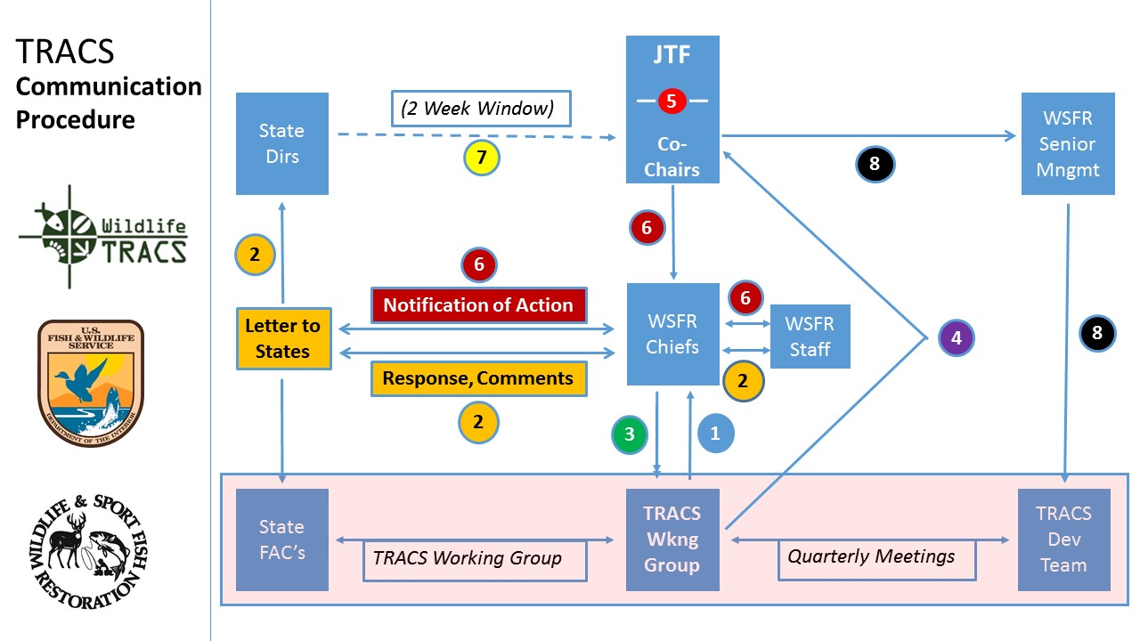
- WSFR Communications Procedure – Tim Smith

This communication chart was presented at the last JTF meeting and was approved. The next step was to come up with the narratives.

The JTF members agreed that 2 weeks is not a large enough timeframe for Directors’ feedback. At least a 3 – 4 week timeframe works better so it is enough time to give feedback if directors are out on travels or vacations. WSFR can make it flexible case by case depending on the urgency of the issue.

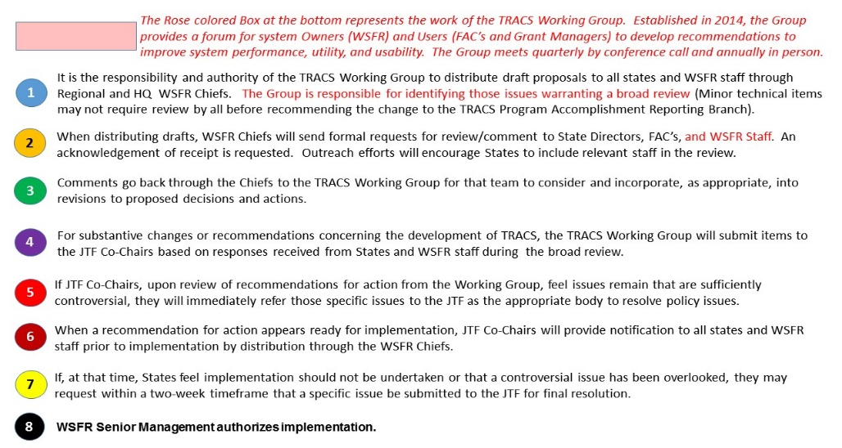
We need to define some decision points in this process before we finalize.

Decision 2 - Approved changes to communication chart

- TRACS Working Group: Approval of Final Matrix – Tim Smith

Decision #10 - “JTF approved the TRACS Working Group to review comments received and revise the Matrix as appropriate for those items NOT addressed by JTF decisions. The TRACS Working Group will utilize the TRACS Communications Procedure diagram for any unresolved issues and will report back decisions consistent with the diagram.”

We took 525 comments and divided them into categories. We created 4 subcommittees to deal with technical issues that were referred back to the TRACS WG to deal with. Comments fell into 4 categories. Red indicates how each category is being dealt with.

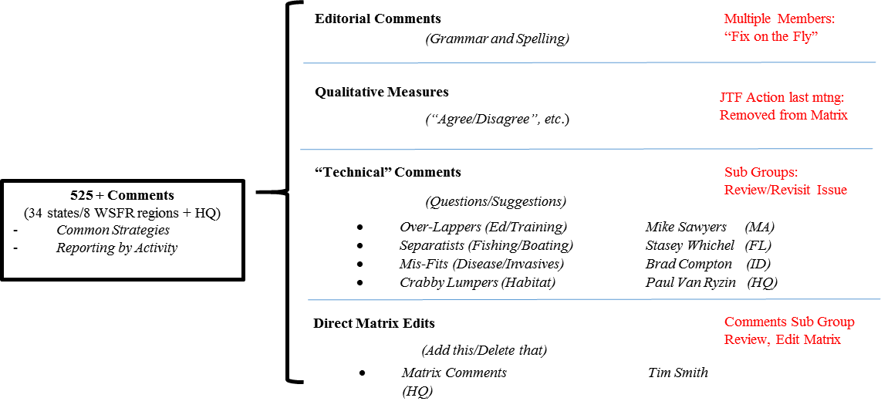
All comments with specific edits that came back were integrated into the matrix and designed a final edited master version of matrix so it is easy to read and understand.

TRACS Working Group requested additional time (approx. 3 weeks) to conduct a Supplemental Matrix Review with:
- Federal Aid Coordinators Work Group
- State Organization for Boating Access
- Aquatic Resource Education Association

The JTF members reviewed the final version for both the Matrix and Wireframe Sub-Groups and adopted it according to the changes made in the communication chart. The changes affected the need for time to allow all regions to coordinate with appropriate people to give feedback, JTF’s need to approve it before it goes out to the states, and the need to distribute the Wireframe for the review.

Tuesday, April 25 JTF-accepted proposal to extended Matrix Review schedule
Thursday, May 4 Comments Sub-Group reviews/resolves matrix “technical” issues
Full TRACS Working Group holds Matrix Work Sessions:
Tuesday, May 9 Session #1: Common Strategies; SMART Objectives; and Measures
Monday, May 15 Session #2: Activities (Tag 1);
Session #3: Descriptions
Wednesday, May 17 Matrix sent to Stakeholders groups for Final Review (FACWG; SOBA; AREA)
Week of June 19 Comments compiled and submitted to Dan/Tim; Populate final matrix
Monday, June 26 TRACS Working Group call to finalize Matrix Completion Process
Wednesday, June 28 Forwarded by WSFR Chiefs to State Directors for four-week “Consensus” review
Wireframes distributed to FAC’s and WSFR Users
Friday, July 28 Deadline for Directors response to JTF Co-Chairs
Week of July 31 Matrix presented to JTF for Acceptance
Week of August 7 TRACS Working Group Wireframes Review Meeting in Denver (3-days)

Decision 3 - Matrix Proposed Extended timeline was approved

Action Item 9 Matrix Proposed Extended timeline to be distributed to JTF, FAC, regional Chiefs – Tim Smith / Silvana Yaroschuk by April 26, 2017
- 5-Year Report Indicators – Tom Busiahn

This is a partnership effort between WSFR and States that will help identify outcome indicators to communicate a WSFR performance story. It will be online which it will make it accessible and easy-to-read. TRACS will collect some of the data to use for future reports. The survey was sent to states and we received a good response. The survey had 3 sections according to the availability of data. Concerns emerged over unavailable data, indicators not being closely linked to WSFR’s objectives, differences between states in terms of policy, data collection methods, and demographics making inter-State comparison difficult, concerns about how the SWG program fits into these metrics, whether it will be properly represented in findings, and interest in who would be reading the report.
We have four requests:
- The JTF endorses the communication of high-level outcomes to showcase achievements of the WSFR partnership in the 5-year report.
- The JTF cautions that the 5-year report must not purport to set goals or priorities for State agencies in their use of WSFR grant funds. That is the sole responsibility of State governments.
- The JTF urges State agencies to make reasonable efforts to contribute requested data and to review drafts of the report.
- The JTF endorses use of the proposed outcome indicators in the 5-year report with the following stipulations:
  - Use all indicators for which data is currently available without requesting additional data from States (all Section 1 and some Section 2)
  - Use Section 2 indicators (requiring data sharing by States) for which the availability rating is higher than 0.60
  - Highlight the need to quantify two Section 3 indicators in future reports:
    - Effect of recruitment, retention, and reactivation initiatives
    - Hunter and Aquatic Education impacts
  - Use readily-available data to highlight individual State achievements, e.g. CVA in Florida

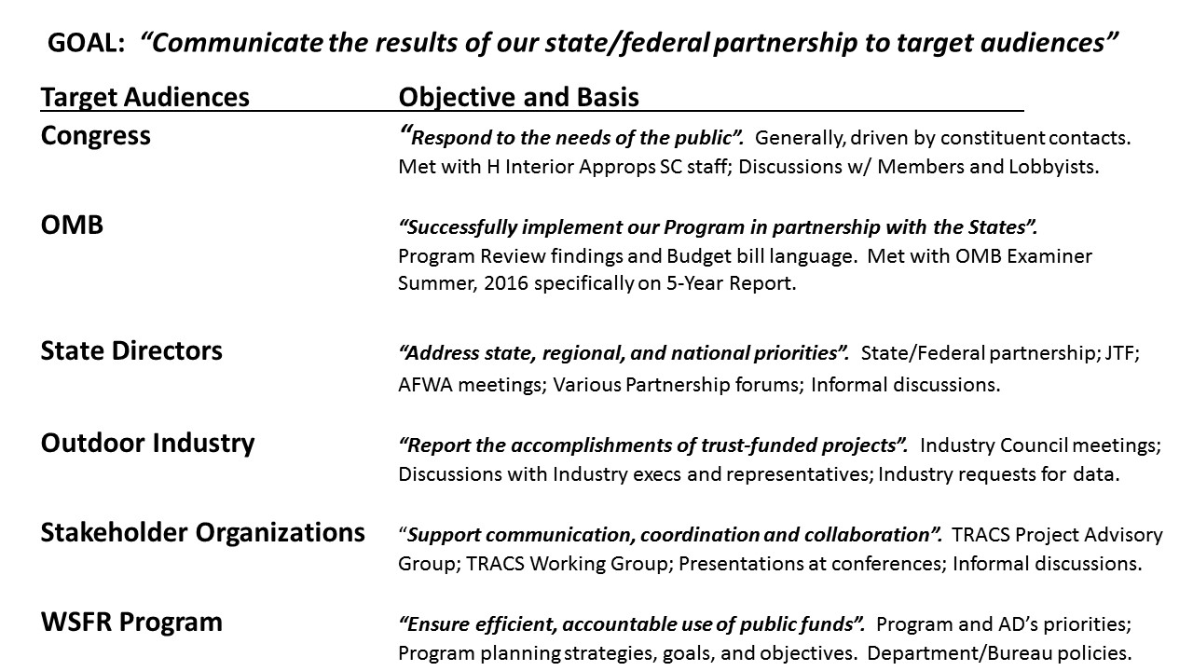

A tool called StoryMaps will be used for the 5-year report, with visual and graphic presentation of data, and the report will be online. We have not designed the executive summary yet.

Members proposed a communication strategy for the 5-year report to identify the audience, grade level, and other issues so everybody can see what this report might look like at the end.

Everyone will need time to look at it but also we do not want to wait until the next JTF meeting to approve it, so we need to arrange for a conference call.

Those target audiences are critical decision-makers in their own right and need to be informed by this 5-year review. A communications plan might be the next iteration of how to make sure this 5-year review serves us in reaching these target audiences.

At the Business Summit, industry asked for information but not specific kinds of information. Industry wanted to see more high-level information—a big picture they could point to as successes to the program. WSFR sent out the same request that went to the States in order to get better feedback. WSFR is aiming to get something out there that they think hits the mark with the information they have at right reading level and then they can get responses back, then recalibrate.

WSFR needs to present where they are in this process, not from the schedule standpoint but in terms of details so people can start to form impressions. WSFR can provide a briefing to JTF.

Action Item 7 - Set up a conference call with JTF members – Silvana Yaroschuk
- Follow up on matrix
- Briefing on 5-year report process and available information and provide to JTF

- SWG Effectiveness Measures

This refers to a set of metrics evaluating the effectiveness of State Wildlife Grants (SWGs) adopted in April 2011. There is a significant difference between this and TRACS, and those Effectiveness Measures (EMs) were specifically developed for SWGs.
TRACS Enhancement Outcomes shared methodologies with SWIGs EMs:
- Identifying the most common generic conservation;
- Describing, via a results chain, how the action will lead to desired impacts;
- Identifying effectiveness measures to assess progress at key points through project lifecycle;
- Incorporating project outcomes measures into the TRACS data system;
- Collecting, analyzing and sharing Effectiveness Measures data

Benefits on going back and revisiting the SWF EMs and willing to assist and find a way to incorporate in TRACS there are few conditions to that:

Benefits:
- Provides a level of detail expected of appropriated programs;
- Provides support for Blue Ribbon Panel efforts;
- Provides important data to continued efforts to conserve SGCN.
Conditions (WSFR conditions in order to reach some agreement before proceeding):
- JTF needs to endorse;
- Specific measures need to be required – it requires extensive process on AFWA side to go back and review those measures to get them in shape
- SWG Measures “fire-walled” from the TRACS Enhancement Measures;
- SWG EM process cannot impede development of the TRACS Enhancement

Here is the timeframe for the process, which will end up with some development requirements that we can begin looking at a year from now:

May, 2017 AFWA/WSFR convene a Working Group;
July, 2017 Initial Workshop to review the recommended SWG EM Measures
September, 2017 Brief Wildlife Diversity, Conservation and Funding Committee
December, 2017 Draft set of Measures presented to JTF
January, 2018 TRACS Working Group Workshop scheduling discussion
March, 2018 Final Draft EMs presented to Wildlife Diversity, Conservation and Funding Committee
May, 2018 Final Draft presented to JTF for approval
June, 2018 Final requirements presented to PAR Branch for development

When the system was created, we felt that there was a fundamental difference between how we needed to track/report and justify the expenditures appropriated by the Congress versus ones created from hunters/anglers community/industry. Therefore, we have been working for a long time on TRACS and now we are talking about going back and grabbing SWIGs EMs.
The vast majority of Northeast Region States have identified TRACS as a mechanism that States will use to measure and track effectiveness. State Wildlife Action planners in the NE Region feel strongly about EMs and the 2011 document. But the 2011 document and TRACS Enhancement Measures are far apart. There is a lot to do to figure out if these two systems can be integrated and whether TRACS is the right place for SWG EMs.
We need to have some discussions between the State side of JTF and AFWA on how to move forward.
AFWA Action Items 3 - Discussions within AFWA on SWGs EMs
- Real Property Chapter – Lisa Van Alstyne

Tom Barnes sent out Chapters 6, 7 and 8 for comments, responded to the comments, and sent it out again. He is also working on the development of the new appraisers training. He was hoping to have the chapters ready but will not be done until the end of summer. Tom is going through chapter 8 right now and looking through some complicated issues that need more work and coordination. What we are proposing is to have those chapters ready for publishing around November, giving everyone a couple of months to get used to them, and in late January early February start making trips around. We are going to meet with Mike Sawyer and if anyone else feels the need to meet and discuss between now and November let us know.

A couple of months would not be enough for states so 6-8 months to work with it would be more realistic—especially accounting for rollover of the State fiscal year.

Action Item 8 WSFR will communicate the proposed timeline on Real Property Chapter –Lisa Van Alstyne by May 5, 2017

Decision 4 The JTF endorsed the new proposed Real Property Chapter Schedule

- Administrative Funding Analysis Update – Tom Busiahn

WSFR and the contractors from PriceWaterhouseCooper (PWC) conducted meetings in each of 8 Regional offices. Those meetings, conducted by mid-April, included some state representatives such as directors, Federal Aid Coordinators and also WSFR Regional staff and Regional chiefs. We are still planning on meetings with WSFR headquarters and industry representatives.

The results of the meetings showed common themes. State priorities include the timeline of grants, interpretation of policy, and guidelines for grants. From the feedback it looks like the relationships with Regional Offices are generally very good.

The next step is to summarize this information in a report that will cover all activities under WSFR program; after that, we will look at the cost of delivering those activities, and some recommendations from PWC developed in conjunction with WSFR and strategies for implementing those recommendations. This work will be done by late summer and will be available before AFWA meeting in September. We are pleased with the participation in meetings.

There are 4 phases to this process:
- 1. Gather and produce the report on the data
- 2. Look at the cost of each component
- 3. Develop an approach for the implementation
- 4. Determine whether there are any legislative changes

The goal is to bring this to the Trust Fund Meeting at AFWA’s Annual meeting and have a discussion there. If we plan to make changes, we must have consensus and support of State partners and industry.

One of the concerns raised by JTF members was about the last two questions where they had to say they were not willing to pay more for less service or were willing to pay more for increased service. The question that was not asked was whether or not they would prefer reallocation of existing resources.

The other theme that came up was restoring the Regional budgets, with the sense that some activities conducted from Headquarters are not of high value to the States and some of those resources should be reallocated to the Regions. This should be kept in mind during the review.

- National WSFR and Federal Aid Coordinators meeting – Bob Curry

We are looking to postpone this meeting until Fall 2018. One of the things that drives when it will happen is having fulfilled all final requirements for a workable product that WSFR can look at.

We talked about the new process we have to go through to get grants approved. One of the 2 grants waiting for the review is this one. In addition, we do not need to have TRACS fully functioning but must have the TRACS training.

