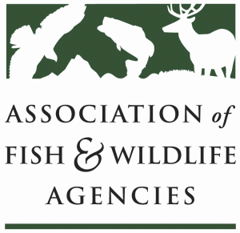

Human Dimensions and Social Science SubCommittee
Chair: Ann Forstchen (FL)
Staff: Dr. Jonathan Mawdsley (AFWA)

Thursday, March 12, 2020 1:00 pm to 4:00pm

North American Wildlife and Natural Resources Conference
Room: Murray
Hilton Omaha
Omaha, Nebraska

Committee Charge: 1) provide a forum for discussion of human dimensions and social science
research and applications in state, federal and provincial wildlife and natural resources agencies and
partners. 2) advise the membership and leadership of the Association regarding human
dimensions and social science research and applications

Agenda
1:00 - 1:15 Call to Order, Welcome and Introductions, Review Agenda
Ann Forstchen, FL FWC

1:15 – 1:30 Human Dimensions and the Relevancy Roadmap (Ann Forstchen – FWC)

1:30 – 1:50 Human Dimensions networking/Expert Directory on HD.Gov (Natalie Sexton, USFWS)

1:50 – 2:10 Human Dimensions and Joint Venture Implementation Plans (Ashley Gramza, AGF)

2:10 – 2:30 Summary of USFWS Social Science Summit – (Natalie Sexton, USFWS)

2:30 – 2:50 Summary of Pathways HD Conference (Natalie Sexton, USFWS)

2:50 – 3:10 Summary of 3/10/20 HD Session on HD successes and challenges in state agencies (Mike Quartuch, CPW)

3:10 – 3:45 Elevating Social Science for Conservation Organization Directors – what might this look like? (Ann Forstchen, FWC and all)

3:45 – 4:00 Summary of Action Items and Wrap-Up
Ann Forstchen FL FWC, all

4:00 Adjourn

