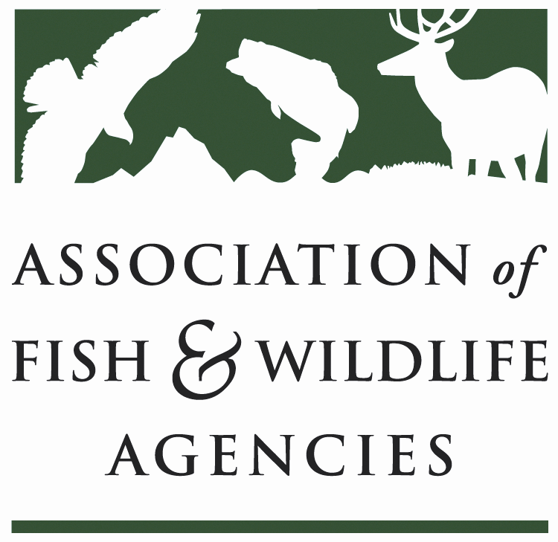
Science & Research Committee
Chair: Russ Mason (MI)
Vice-Chair: Jason Sumners (MO)
March 11, 2020
1:00 PM – 3:00 PM
North American Wildlife and Natural Resources Conference, Omaha, Nebraska

Agenda

- Call to Order/Review Agenda/Introductions (5 minutes)
Russ Mason (MI)

- Programmatic Updates (30 minutes)
  - National Cooperators Coalition update John Kennedy (WY) (10 minutes)
  - Human Dimensions Subcommittee Update Ann Forstchen (FL) (10 minutes)
  - Monarch Butterfly Conservation Science Plan Ed Boggess and Claire Beck (MAFWA) (10 minutes)

- New Topics (50 minutes):
  - Innovative Use of Tissues from CWD-positive Deer Herds in Research Tracy Nichols, USDA (20 minutes)
  - Disease Transmission Risks from Carcass Disposal in Landfills (10 minutes)
  - Modeling Effects of Deer Harvest Regulations on CWD (10 minutes)
  - Wildlife Professionals’ Views of Their Roles: 1999 and 2019 (10 minutes)

- Committee Discussion: State Agency Science Needs Survey (35 minutes)
  - Analysis of Results to Date: David Scott (USFWS) & Jonathan Mawdsley (AFWA) (15 minutes)
  - Committee Perspectives and Discussion: Implications for Committee Work (10 minutes)

Objectives and Desired Outcomes for Committee Discussion:
  - Identify priority topics for future meetings and committee work, based on responses received

- Adjourn

