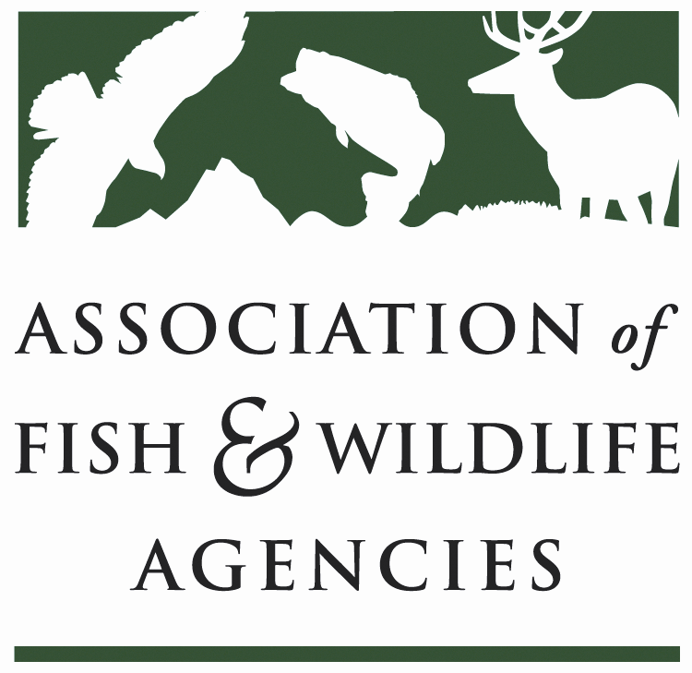

Leadership and Professional Development Committee
Chair: Dave Golden (NJ)
Vice-Chair: Mike Fowlkes (UT)

Date: Tuesday, March 10
Time: 10am – 12pm

North American Wildlife and Natural Resources Conference
Hilton Omaha
Omaha, NE

Agenda

10:00 am Call to Order/Review Agenda

10:05 Introductions

10:10 Approval of Minutes for the 109th AFWA Annual Meeting /Approve Committee Charge

10:15 MAT Report (Gina Jackson)
- MAT Activities
- NCLI Activities

10:30 LPD Survey Results (Bettina Fiery)

10:45 Adaptive Leadership Working Group report (Charlie Sperry)

11:15 Agency Self-Assessment Tool (Chris Smith & Ann Forstchen)

11:45 Leadership Program Updates (NJCLP, NC CLP, Western & Northeast CLP Development)
11:55 Wrap-up Discussion

12:00 Adjourn

