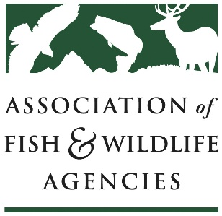
Climate Adaptation Committee
84th North American Wildlife & Natural Resources Conference
Thursday, March 7, 2019 | 1-3pm | Plaza Court 4
Chair: Stafford Lehr (CA)
Vice-Chair: Thomas Eason (FL)

Meeting Agenda
1:00 Call to order, introductions, review of agenda
Stafford Lehr, CA DFW / Thomas Eason, FL FWC
1:05 Colorado Climate Adaptation Activities
George Schisler, CO DNR
1:20 Update on Florida Climate Adaptation Activities
Thomas Eason, FL FWC
1:35 Climate Adaptation Science Center Updates
Aparna Bamzai, North Central CASC/USGS
1:50 Southeast Climate Adaptation Strategy overview and update
Mallory Martin, USFWS
2:05 Climate Change and Conservation in the Southeast: A Review of State Wildlife Action Plans
Bruce Stein/John Kanter, NWF
2:20 Climate Change Vulnerability and Adaptive Management of Wildlife Habitats in the West
Healy Hamilton, NatureServe
2:35 Roundtable
3:00 Adjourn

For more information, contact Maggie Ernest Johnson at mjohnson@fishwildlife.org

