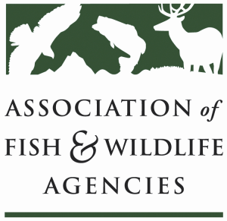

Resident Game Bird Working Group
Chair: Karen Waldrop, Kentucky Department of Fish and Wildlife
Vice-Chair: Todd Bishop, Iowa DNR
7 March 2019
3:00 – 5:00 PM
84th North American Wildlife and Natural Resources Conference
Sheraton Denver Downtown
Denver, CO

Agenda

3:00 Call to Order/Introductions/Review Agenda
Karen Waldrop, KDFWR

3:05 Approval of Minutes for the September 2018 meeting
Karen Waldrop, KDFWR

3:10 Non-Government Partner and Management Initiative/Plan Updates
National Wild Turkey Federation
Pheasants Forever/Quail Forever
National Wild Pheasant Conservation Plan
National Bobwhite Conservation Initiative
North American Grouse Partnership
Sage Brush Initiative
Lesser Prairie Chicken Initiative
Western Quail Working Group
Spruce Grouse Partnership
Ruffed Grouse Conservation Plan
Chukar/Hungarian Partridge Plan
Others

3:30 Translocation
Review of National Template – Robert Perez, TPW
Next Steps – Group Discussion

4:20 National Gamebird Harvest Data Collection
Scott Taylor, National Wild Pheasant Conservation Plan

4:50 R3 and Gamebirds – Scott Taylor, Group Discussion

If Time Allows Grassland Initiatives – Natives First
Other Ideas

5:00 Adjourn

