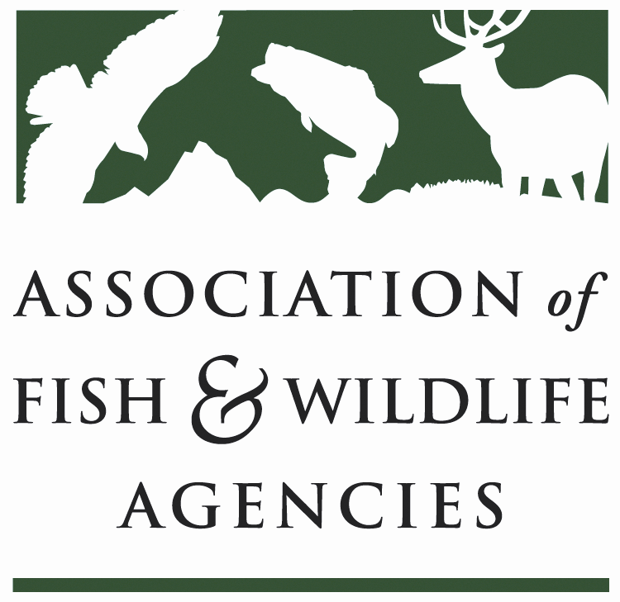

84th North American Wildlife and Natural Resources Conference
Sheraton Denver Downtown
Denver, Colorado

Sustainable Use of Wildlife Committee

Thursday, March 7, 2019
8:00 a.m. – 12:00 p.m.
Committee Charge:
Advocate the North American Model of Fish and Wildlife Conservation and promote the sustainable use of fish and wildlife resources at the international level.

Chair: Terry Steinwand Vice-Chair: Dave Kay

Subcommittees and Working Groups:
U.S. Furbearer Conservation Technical Working Group

Agenda
- Review of agenda and call for adjustments; Opening Comments (Steinwand)
- National Conservation Needs Submission for the 2020 Grant Cycle from the Committee (Decker, Batcheller)
- Update on Progress of Multistate Conservation Grants received under the 2019 NCN by the Committee (White, Decker, Trusso, Hiller)
- Sportsmen’s Alliance Update (Houghton)
- Wild Earth Guardians vs USFWS lawsuit on CITES Appendix II Export Program (Hahn)
- Joint Management Committee Meeting on the Agreement on International Humane Trapping Standards 2018 (Deliberto, Kay)
- Safari Club International Legal Updates (Anna Seidman/Doug Burdin)
- Conservation Leaders for Tomorrow Program (Lowe, Windsor)
- Trapping Matters Workshops and Fur Schools (White)
- Best Management Practices for Trapping: Progress and Plans (White)
- Agreement on International Humane Trapping Standards in Canada (Kay)
- Other topics potentially affecting Sustainable Wildlife Use (Steinwand)

