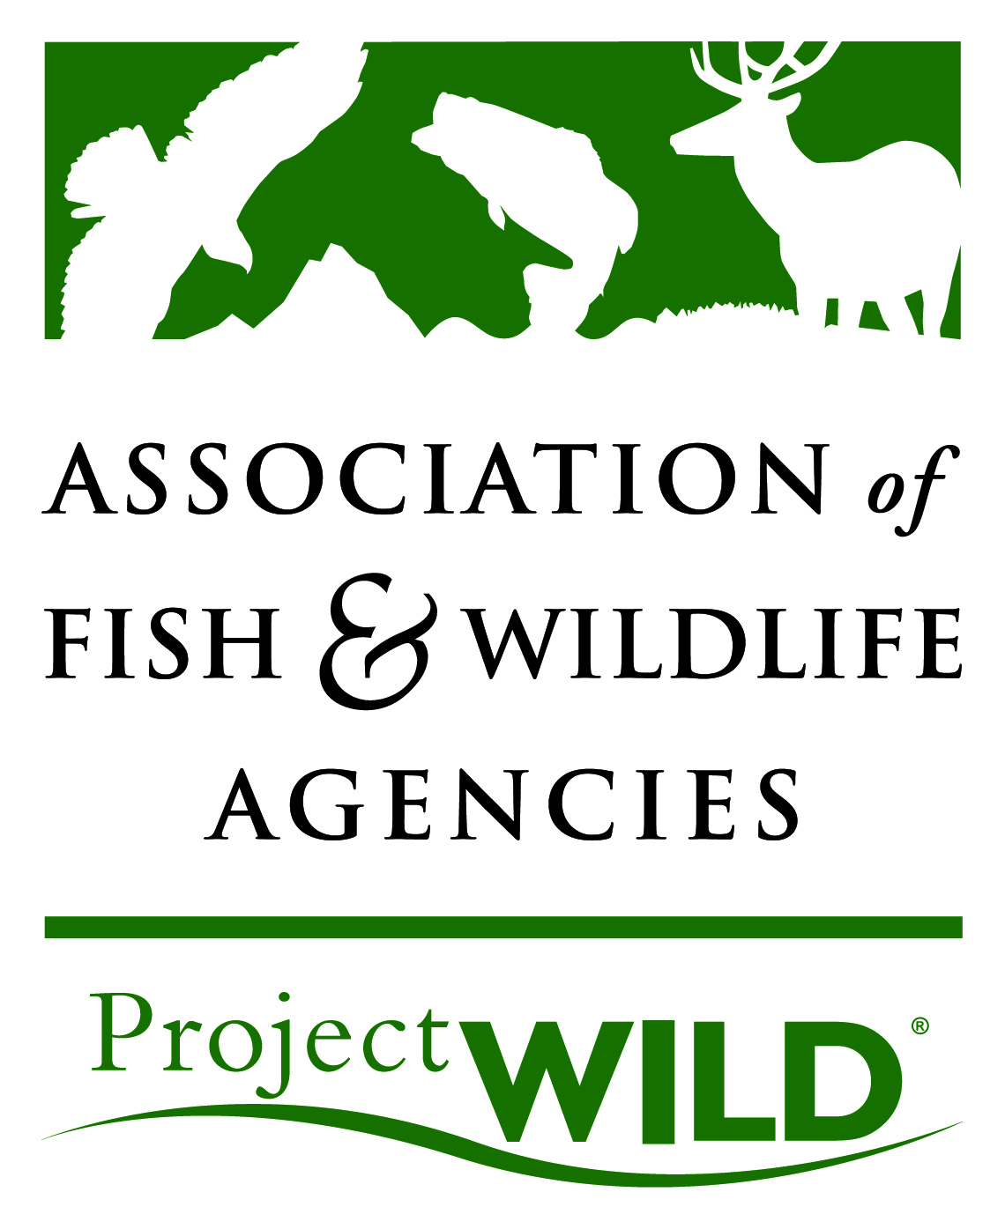

Request to Reprint/Adapt a Project WILD Publication

Please answer each of the questions below and email this form to:
projectWILD@fishwildlife.org. Include “Reprint Request” in the subject line.

Name: Are you a teacher? _____ Publisher? _____ Other? _____

Organization: Is your organization private or non-profit? ___

Address: Phone:

E-mail: Website:

Which Project WILD publication are you requesting activities from?

Please list the exact title(s) and page numbers of activity(s) to be used, including the copyright year of the publication:

How many copies of this publication will be published?

State intended purpose:

Will the publication be sold? If yes, please explain:

How will the publication be distributed?

Anticipated number of copies to be distributed: Geographic range of distribution:

Time period of distribution: Who is the target audience?

Will the publication be reprinted? If yes, please explain:

Is the reprinted/adapted material going to be distributed by anyone other than the party requesting this permission? If yes, please list the names of all parties intending to distribute the material:

Are you intending to modify/adapt the activity(s)? ______ If yes, please include a sample copy of the modified/adapted activity(s) for review.

Are you working with Project WILD (local, state, national, international) on this project?

If permission is granted, the activities must appear as printed hard copy materials only and not published in electronic format. Reprint fees typically apply.

