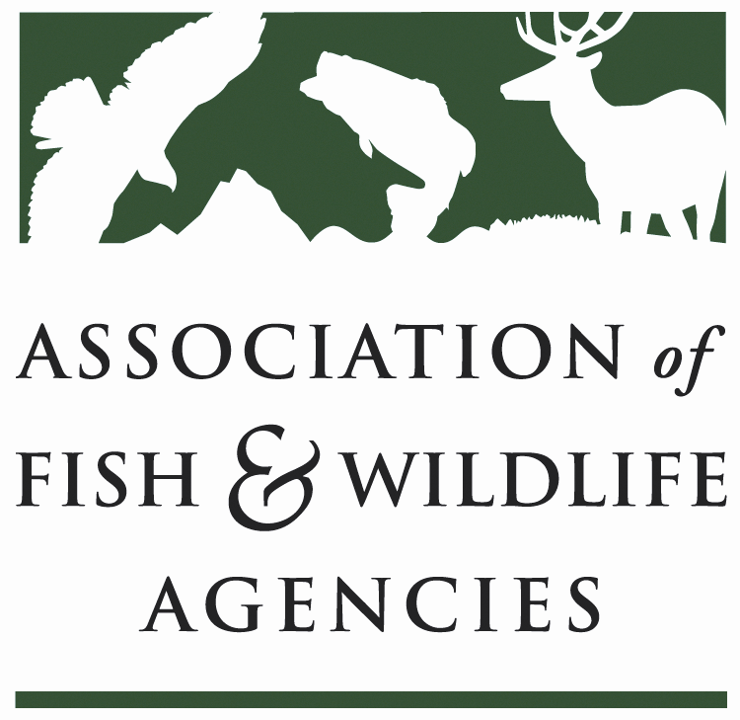

Energy & wildlife policy Committee
Chair: Paul Johansen (West Virginia)
Vice-Chair: Keith Sexson (Kansas)

Tuesday September 11, 2018
1:00 – 5:00pm
AFWA Annual Meeting
Grand Salon C
Tampa Marriott Waterside Hotel | Tampa, FL

Agenda

1:00 Call to Order and Introductions
Paul Johansen, West Virginia Division of Natural Resources
1:10 Approval of Minutes from the March 2018 Meeting
Paul Johansen, West Virginia Division of Natural Resources

1:15 Update on the Committee’s National Conservation Need
Mark Humpert, AFWA

1:20 State Roundtable
One representative per state agency highlights one legislative, policy, or management initiative or issue

1:45 Recovering America’s Wildlife Act & Alliance for America’s Fish and Wildlife
Sean Saville, AFWA (invited)

2:00 Update on Recent USGS Energy Development and Fish and Wildlife Management Research
Mona Khalil, US Geological Survey

2:15 Enhancing Working Agricultural Lands and Wildlife Habitat near Energy Sites in North Dakota
Jesse Beckers, North Dakota Natural Resources Trust

2:30 AWWI 10-Year Anniversary, AWWIC Database and Wind Wildlife Research Meeting
Taber Allison, American Wind Wildlife Institute

3:00 -Break-

3:15 Bat and Wind Energy Cooperative Research Priorities
Mylea Bayless, Bat Conservation International

3:30 Report from the US Fish and Wildlife Service
Gary Frazer, USFWS (invited)

3:45 Georgia Partnerships: Working to Avoid Impacts to At-risk Species during Solar Development
Bob Sargent, Georgia Wildlife Resources Division

4:00 Committee Work Plan-Input from Committee Members
Paul Johansen, West Virginia Division of Natural Resources
Mark Humpert, AFWA

4:30 Wrap-up Discussion & Action Items

5:00 Adjourn

