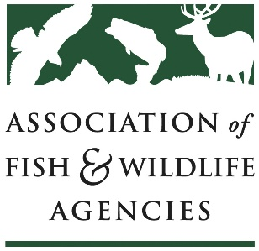
Climate Change Committee
Association of Fish & Wildlife Agencies Annual Meeting
Monday, September 10, 2018 | 10am – 12pm | Room TBD
Chair: Bruce Dale (AK)

Meeting Agenda
10:00 Climate Adaptation Leadership Awards ceremony
Join us in celebrating the winners and honorable mentions of this year’s Climate Adaptation Leadership Awards for Natural Resources! The Awards recognize outstanding leadership of individuals, organizations, businesses, and agencies to promote natural resource adaptation in a changing climate.
10:45 Call to order, introductions, review of agenda – Maggie Ernest Johnson, AFWA
10:50 Preliminary results of 2018 Climate Adaptation Survey – Maggie Ernest Johnson, AFWA
11:00 National and Regional Climate Adaptation Science Centers – Doug Beard, USGS/NCASC
Report on the National and Regional Climate Adaptation Science Centers (CASCs) followed by a listening session where states can provide feedback on how CASCs can better engage with their work, research priorities, and opportunities for partnership.
11:20 Florida Climate Adaptation Activities – Lily Swanbrow Becker, FL FWC
Report on Florida FWC climate adaptation activities.
11:40 Roundtable updates on climate adaptation work – Bruce Dale, AK DFG
Participants should be prepared to address 1-3 priorities for the coming year and if their state is doing anything specifically to implement the National Fish, Wildlife, and Plants Climate Adaptation Strategy.
11:55 Proposal to change committee name to Climate Adaptation Committee – Maggie Ernest Johnson, AFWA
12:00 Adjourn

For more information, contact Maggie Ernest Johnson at mjohnson@fishwildlife.org

