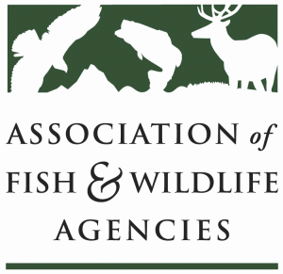

Amphibian & Reptile CONSERVATION Committee
Chair: Cathy Sparks (RI)
Vice-Chair: Thomas Eason (FL)

Tuesday, September 11, 2018
9:00 am to noon (ET)

AFWA Annual Meeting
Room: TBD, Tampa Waterfront Marriott
Tampa, FL

Agenda
9:00 am Call to Order, Introductions, Review Agenda
Cathy Sparks, RI DEM

9:15 Florida Amphibian and Reptile Conservation Activities
Brooke Talley, FL FWC

9:45 Briefings
PARC Strategic Plan/Implementation Plan, and national updates
Thomas Eason, FL FWC
CITES activities re: freshwater turtles and other herpetofauna issues
Deb Hahn, AFWA/Carolyn Caldwell, MAFWA

10:00 BREAK

10:15 Bsal Updates and Discussion
Bsal Research Findings, Next Steps
Matt Gray, University of Tennessee-Knoxville
State-level efforts to address interstate movement of injurious wildlife (e.g., amphibian import restrictions for Bsal concerns)?
Thomas Eason/Brooke Talley, FL FWC

11:00 Recovering America’s Wildlife Act
Sean Saville, AFWA

11:30 Roundtable: State Regulatory Changes for Herpetofauna, or other announcements?
All

11:55 Action Items/Wrap-Up
Cathy Sparks, RI DEM

noon Adjourn

