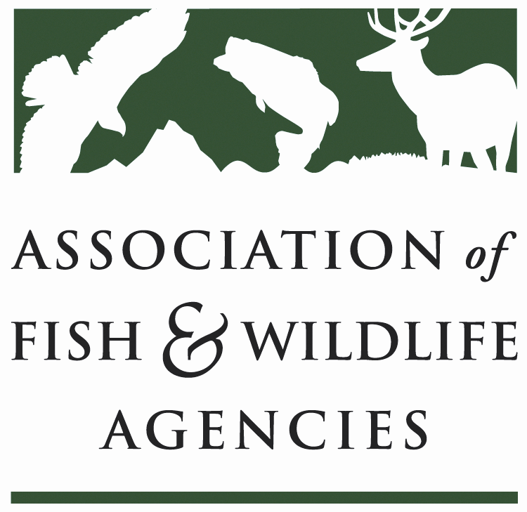

Fisheries and Water resources Policy
Chair: J.D. Strong (OK)
Vice-Chair: Larry Herrighty (NJ)

Thursday, March 29th, 2018
8:00 am – 12:00 pm
Salon C
Hilton The Main

83rd North American Wildlife and Natural Resources Conference
Norfolk, VA

Draft Agenda

8:00 am Call to Order/Introductions/Review Agenda – J.D. Strong, OK
- Action: Approval of Draft Meeting Agenda/September 2017 minutes

8:10 Subcommittee and Working Group Reports
- Subcommittee on Water – Chris Cantrell, AZ, Jon Sjöberg, NV
  - WOTUS
  - Fish and Wildlife Coordination Act improvements
    - Survey to determine where there are issues
  - Flow 2018 - Handout
- Drug Approval Working Group - Devin DeMario, AFWA
  - February 2018 – Aquaculture Meeting
    - 16 individuals
    - Drug companies were in attendance
    - Steve Sharon’s last meeting
    - Dr. Mark Clifford (CA) and Alan Johnson (IA) will be taking over
  - 5 gallon containers for hydrogen peroxide are available with issues in DHS
  - VFD for antibiotics in feed – Now all require veterinarian
  - Aquatic health needs survey was completed
    - Key information for priorities of AADAP workshop
  - Next meeting in Tampa at AFWA

8:40 Update from AFS Fisheries Administration Section – Joe Larscheid, AFS/IA
- Met all afternoon yesterday on a broad range of issues including AFS journal relevance

8:50 Waters of the U.S. Rulemakings: Status and Next Steps – John Goodin, EPA
- Plan sent out implementing two stage process
  - Rescind rule and send back to 1980s regulations
  - Replacement rule based on Rapanos case
- Geographic scope is the key to implementing all parts of the Act
- Consultations commenced last year with tribes and states
  - Along with other stakeholders
- Two day workshop occurred last March with state agencies
- 670,000 comments received
- SCOTUS ruled that 2015 lawsuits will go to District Courts
  - November rule delays implementation for 2 years
- Wanted to hear from states on key factors for implementation
  - Scalia opinion – Nature of tributaries and wetlands
    - Long known the connection of ephemeral streams and systems to navigable streams – How to influence
      - Provide literature on basis of connection or connectivity (everything is connected hydrologically from previous work)
      - Implications of no federal jurisdiction
        - Downstream state issues with upstream states with lower standards
  - Navigable waters to 2015 rule making level
  - How far does federal jurisdiction go
  - How close to wetlands have to be to tribs – Touching – Connected – Isolation
  - Exclusions
    - Private converted cropland – After 12/1985
    - Waste treatment exclusion – Often mining related
    - Along with others
  - Wanted to have regionalization and ability to implement – Particularly in SW
- Provisions of CWA
  - Broad range of programs (Sections 401, 402, 404…) effected
    - Where are discharge points – Regulated or not
      - Direct connection of trib to downstream waters of a point source discharge – If reduced in federal range, does not have to go at end of pipe into navigable water to be considered in Section 402 regulation. Some states regulate at above the discharge point.
- Do states have programs in place to protect fisheries if changes made?
- Federal and State – looking at balance of state and federal authorities (Sections 101a and 101b)
  - Many states have a “no more strict than federal” laws
  - Could rulemaking be delayed to allow for state law updating? Will be considered
- Time periods
  - Draft rulemaking in late March to OMB with notice in summer – Comment periods 60-90 day periods
  - Final rulemaking maybe 1st of next year
  - Preamble on background and other information – Reports on environment and economic effects – Good place for FW agencies to provide information
    - Best information for FW agencies to provide will be fisheries focused information on the line where jurisdiction changes. Any information will be welcome.
- Will an economic analysis be done and include environmental values? There will be an economic analysis
- Court Cases
  - District courts reviving earlier cases
    - ND case moving forward as of last week
    - Many cases moving on the abeyance of 2015 rule
- Fishable water criteria – How would AFWA assist? States have engaged with fisheries management information. Should be raised in comments and proposed rule-making will be protective.
- Unclear if rule will have a range of options or one
- Environmental analysis will be different from NEPA but will have an analysis on jurisdiction
  - Section 303 – Water q uality standards with many states much broader on jurisdiction waters
- Timing of comment periods will directly on top of the highest workloads for FW agencies

9:20 Mitigation Banking – Steven Martin, ACOE
- Mitigation Banks
  - About risk management
  - Mitigation Banks
    - Private or public sponsors
    - Sites known in advance
  - In lieu Fee Programs
    - More oversight and audits
    - Public or NGOs
    - Fees received before
    - Time limit – 3 growing seasons
    - Site numbers range from 60-120 per site
  - 800 sites at 110K acres and ¼ streams – 800K acres
    - Many are conservation banks
  - Interagency Review Team
    - Regulatory and resource agencies
    - Oversee operations – Plans, credit release requests, instrument modifications, adaptive management
  - Have almost none in MI
  - Credit types
    - Wetlands
    - Streams – Ephemeral to permanent
    - Others – Restoration of shellfish areas, connectivity projects and contaminated site cleanup
- 150 Conservation Banks – 180K acres for 70 species with focus in CA
  - FL Panther movement
  - Salmonid habitat
  - Listed mussels
- Benefit
  - Habitat conservation
  - Access to habitat
  - Recovery for at risk – In-Leiu – Compensation Planning Tool following SWAP
    - ME – Implement projects to improve ATS passage
    - AZ – CO River effects focused on listed and endemic fishes – i.e. Bonytail chub
- Opportunities
  - Looking for more input from FW agencies on interagency teams
    - Conference upcoming
  - Sponsoring mitigation banks – State agencies can sponsor mitigation banks or in-leiu fee programs (MA, AZ and KY)
  - Landowner participation – Rehab sites or take properties that have been rehabbed
    - TN, AL, WV have taken ownership
    - Need to have maintenance funds for permanent management
- Discussed having a Habitat Banking session at the 2019 Joint Meeting with AFS – TWS
- Acquisition of water rights – Could be an option
  - MT has done this for flowage easements
- AFWA has been invited to have a seat at the May mitigation conference – Requesting assistance
9:35 National Fish Habitat Partnership Update - – Tom Champeau, FL
Gary Whelan, MI
Ryan Roberts, AFWA
- Updates
  - Board membership - 22
    - States
    - Federal agencies
    - NGO Community
    - Professional Association
  - Board Update
    - 20 partnerships
    - 10th anniversary
    - Different focus areas – Species, Area and Habitat Type
    - Board will review partnerships – Learn what work is being done
    - Consistency with Fish Habitat Action Plan is a key Board role
    - Discussed staff changes – Alex joined from NOAA
    - Partnership networking key
      - 700 projects with 3:1 fund ratio
      - Close working relationships with local entities
    - Provided examples
      - Shelikof Creek AK – SEAKFHP
      - PA statewide work – TU $4.5 million to $500K
    - Legislation
      - Came close last year
        - Senate there is movement
        - House movement is occurring
      - Board will be larger with marine, private and tribal additions
      - Provides funds to federal agencies for support
      - Secretary selects projects from funds
      - MOU has expired and awaiting
  - Beyond the Pond
    - 501c3 in place
    - All FHPs chapters
    - Bylaws and Board in place with overlap
    - Online donation page
    - Partners
      - BassPro helped with 10 year anniversary video
      - 3% of purchases from Repyourwater to Driftless FHP with more coming - $50K for conservation organizations last year
        - We will be one of 12 entities to get conservation – 10% of sales
    - Improved habitat = more opportunities
      - R3 support
  - Chris Cantrell (AZ) requested support of the National Fish Assessment
    - USFWS
      - Will relook at the Assessment with new funds
      - Top priority are funding of the FHP funding
      - FY2019 budget is similar to FY2018 budget reductions

9:50 Fish and Wildlife Service FAC Update – David Hoskins, FWS FAC
- Omnibus bill passed
- $9 million dollars
  - $2 million Asian Carp
  - $3 million Lake Tahoe
    - Inspection and control of invasive species
  - AADAP increased by $400K – Guppy Blair will be joining
    - INAD – 297 enrollments from 40+ states
- Fish Hatchery – Evaluating all programs over $250K or more – With 2 done (LAT) and 15 more to come
  - Infrastructure will be increased across refuges and hatcheries
- Workforce reductions moving forward
- Fish Health Centers
  - Tier One Centers under AFS
    - Region 2 done
  - LIMS system – Beta testing underway
  - Aquatic Animal Health Policy – Under review
  - MOU for Drug Advisory Board (NOAA and USGS is all set) – on to do list
- Fish Tech
  - Spawning Computer Program – Broodstock management
- Habitat – FHP
  - Now back to engaging
- Fish Passage
  - World Fish Migration Day – USFWS lead
- Sikes Act – $8 million given by USAF
  - Working with Army on a similar work
- AIS
  - $2 million for Interstate and state plan implement – 40 state and 3 interstate - $46K
  - November 2016 last meeting of National Meeting with another meeting June 2018
  - Quagga and zebra mussel work with $400K
  - Prevention work – Ecological summaries developed and voluntary efforts to prevent spread

10:05 Health Break

10:15 USFS Update – Dan Shively, USFS
- Rise to the Future
- Appreciated state input to strategy
- Full strategy is online
- 30 years of lessons learned added into strategy
- 6 points
  - Conserve fish and wildlife resources
  - Enhance access
  - Science delivery
  - Building capacity with professional development and mentoring
  - Natural resources values – Your best waters video
    - Partners key to communication success
- High Priority Action Items
  - National assessment of aquatic biodiversity – Maybe funding source
    - RPA assessments
    - Want to work with Board SDC
    - Need to talk to Dan Shively about AFS paper assessments – Protected vs unprotected lands
  - Research needs assessment
    - Engage broader community to start with USFS then state agencies
  - National needs assessment
    - Survey of National Forest Fish Managers
    - AFS Symposium – Science and Management on USFS lands
  - Fisheries issue this summer on USFS actions
  - Rocky Mt Research Center
    - Release first installation of eDNA data/atlas on Pacific tribs on Bull Trout
    - Rangewide BKT eDNA – East Coast
    - Pacific Lamprey
  - AFS Symposium on resilience
10:30 Additional Federal Agency Updates
- USFWS – 150th anniversary coming up (1871) – Looking for contacts
- AFS is coming up too
10:40 Legislative Update – Devin DeMario, AFWA
- Federal budget
  - FY2018
  - FY2019 – Same reductions at FY2018 – Streamlining government and infrastructure focus
    - AFWA will be providing comments
    - Send to Devin
  - RAWA Bill mentioned again
  - WRRDA
    - Comments to Devin
- Infrastructure
  - Grey plan without green items
  - NPS backlog
- Vessel Incidental Discharge Act
  - Preempts state authority on ballast water and discharge regs
  - USCG oversight and cuts out the state
  - Could move forward in either in NDAA or USCG Auth bill
- Hydropower Legislation
  - Bill in House reported out and over at Senate
    - Fisheries management and water resources a concern
    - Decreased timelines
    - Data and site specific data requirements better in Senate, not ideal.
10:50 American Fisheries Society – Doug Austen, AFS & Scott Bonar, AFS 1st Vice President
- Update on Standard Sampling book proposal and Grey Literature clearinghouse proposal
  - Second edition of sampling book
    - Assessments moving forward – 60 protocols for sampling
    - Need comparable datasets
    - Many sponsors of initial book – 10 years ago
    - Time for new edition – AZ willing to commit to fund some – 2020 to 2021
    - Survey fish chiefs
      - Do you use
      - What works and does not
      - Other waters needed
      - New methods like eDNA
      - Quantitative methods added
      - Collected data and want to add more data
    - Look for support for project
    - European methods being used across countries with greatly improved sample sizes
  - Grey Literature Clearinghouse
    - Will be downloadable
- AFS 2018 Atlantic City
  - 1500-2000 attendees with more symposia (80-90)
  - Maybe a WOTUS workshop
  - Relevance will be a big theme
  - Joint meeting in 2019 in Reno
  - 2020 meeting is 150th in Columbus
  - 2021 meeting is in Baltimore
  - Joint water meeting – 2022 event for 9 aquatic organizations – FBS
- Professional Journals and Publications
  - All journals are free for members
- RAWA and WOTUS key items

11:10 AFWA President’s Taskforce on Angling R3: An Update – John Arway, PA,
Dave Chanda, RBFF
- Included outside members too
- In general, <$250K spent on Aquatic Education and R3 usually in that area
- 23,000 programs on R3
  - Only 8% of programs evaluation
- Recommendations
  - Commit to developing an Angler R3 plan which identifies desired outcomes and objectives
    - Need to fit in strategy plan
    - Need desired outcomes
    - Participation goals
    - Link to partners
    - Use model
  - Reallocate resources to ensure R3 plan is successful
    - Review existing programs
    - Use staff retirements as vehicle using professional help
    - Annual training session and looking for angling connections with RBFF paying travel
    - Relevancy is keep and R3 efforts are critical
  - Have a full time R3 Manager as part of agency’s management team
  - Develop a data system to track and communicate with agency customers
    - Licensing needs to be simple and easy to use
    - Data dashboards- Track them through time
    - Collect emails and text messaging numbers – Reminders are key
  - Establish an information warehouse to share knowledge
    - Inventory of R3 efforts needed with what worked and not
    - Case story being requested
    - Website development with information
    - Training opportunity development and get staff to workshops and conferences along with committees
- No single good program
  - With recommendations implemented, they will have a very good programs
  - Examples coming from VA, FL, FL, FL and TX with full agency participation including watchable wildlife staff

11:25 Fish and Wildlife Service – Migratory Birds Division – Laurel Barnhill, FWS MB
- Double Crested Cormorant and Free Swimming Fish - Next Steps
- Species conflict framework is being adopted by USFWS
  - Will be used for decision making
- Issue is bird experts dealing with a fisheries issue
- Stakeholder engagement
  - Gather info on effects on cormorants and what happened when order changed including other birds
    - What are DCCO eating
    - What are native fish effects
    - What are non-native fish
    - What are commercial and recreation fish catch changes
    - What is economic loss
    - What other questions – Was order working, documentation level, data available on fish, key gaps – Biological thresholds for management and socially acceptable levels
  - Understand social and economic
  - Build a solid foundation to develop options
    - Want to ensure all are covered
  - Engage fish and wildlife agencies
  - Plans for data – Big issue areas
    - Regional meetings – Great Lakes, Atlantic Coast, Central, Western
    - Who – APHIS, State Fish and Wildlife Agencies, USGS and USFWS
    - Facilitated meetings with a third party in Summer 2018 – Need all parties to be notified and AFWA as communication vehicle
      - Some wildlifers want to push this to the Flyways Tech Group
      - Joint Adhoc Working Group between FWR and Bird Group
        - To provide forum for discuss issue and develop solutions
      - Need to include aquaculture and agricultural mechanisms
    - Overlap areas and different viewpoints

11:45 Discussion on FWRP Committee NCN – J.D. Strong, OK/Devin DeMario, AFWA
- Follow up conversation will be best to handle this with a more broad NCN for fisheries
11:55 Identify Follow-up Issues and Next Steps - J.D. Strong, OK
- WAFWA and other meetings should be used as an opportunity for WOTUS discussions
12:00 Wrap-up/adjourn – J.D. Strong, OK

Committee Charge:
Discuss, develop and recommend Association positions related to:
  - Federal laws, regulations and policies concerning water uses, aquatic habitat conservation, fisheries resources and related funding for such programs.
  - Fisheries management practices and emerging issues (e.g. climate change) for both freshwater and marine resources.

Subcommittees and Working Groups:
- Drug Approval Working group
- Subcommittee on Water

