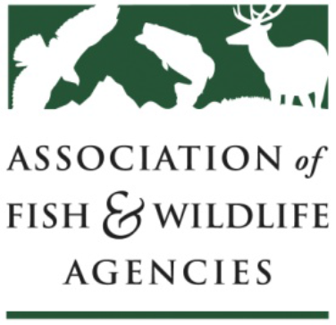
AFWA Committee Work Plan
Worksheet

Guidelines: Each AFWA Committee, Subcommittee and Workgroup is required to review their charge and develop a work plan at the AFWA Annual Meeting and submit to John Lord, Operations Director, jlord@fishwildlife.org by October 1. The purpose of the work plan is to improve communication and effectiveness of committee work and enable committee chairs and the Executive Committee to evaluate their status annually.

Committee Work Plan
Date: September 5, 2017
Committee Name:
INVASIVE SPECIES
Chair: Bill Hyatt | Vice Chair: Kim Bogenschutz | Staff: Priya Nanjappa
Committee Charge:

To provide a national forum for exchange of information and to identify and coordinate needs and actions among state, federal, and tribal agencies, NGOs, and other stakeholders to strategically address high priority invasive species threats and to promote sound policies.

Changes to the Charge:

List Major Activities and Objectives Accomplished During the Last Year:
1. Approved the ISAC whitepaper on Strengthening State-Federal Coordination, and its key recommendations to create a committee to address state-federal coordination on invasive speciesat the local, state, territorial, regional, and ecosystem level and a to hire or designate a full-time National Invasive Species Council (NISC) employee to staff this committee
2. Tracked and solicited feedback on changes to the interpretation of the Lacey Act Title 18 (injurious wildlife) following the DC District Court ruling in April 2017
3. Initiated updates to the AFWA joint MOU with the Pet Industry Joint Advisory Council (PIJAC) and FWS
4. Held between-meeting call in August to maintain communications and engagement between meetings.
5. Provided AFWA representation on both Invasive Species Advisory Council (ISAC) and Aquatic Nuisance Species Task Force (ANSTF)

List Activities and Objectives that Will be Accomplished in the Coming Year:
1. Convening of workgroup to propose, discuss, and finalize edits and updates to FWS-PIJAC-AFWA MOU.
2. Implementation of revised MOU, and related working groups and tasks.
3. Convening multi-committee workgroup to address short-term state level model language to address interstate movement of invasive species, and long-term potential and strategic fixes to the injurious wildlife provision (Title 18) of the Lacey Act.
4. Convening a workgroup to enhance collaboration among state fish & wildlife agencies and state departments of agriculture for invasive species management, using the Sagebrush Ecosystem as a pilot.
5. Continued tracking of invasive species legislation and opportunities for the committee to engage.
6. Assisting NISC in implementation of the ISAC whitepaper on Strengthening State-Federal Coordination.

Comments:

Subcommittee Work Plan
Date:
Subcommittee Name:

Chair: | Vice Chair: |  | Staff:
Subcommittee Charge:

Changes to the Charge:

List Major Activities and Objectives Accomplished During the Last Year:
1.
2.
3.
4.
5.

List Activities and Objectives that Will be Accomplished in the Coming Year:
1.
2.
3.
4.
5.

Describe any Changes you Anticipate to the Subcommittee:

List Subcommittee Members:

Comments:

Workgroup Work Plan
Date:
Workgroup Name:

Chair: | Vice Chair: |  | Staff:
Workgroup Charge:

Changes to the Charge:

List Major Activities and Objectives Accomplished During the Last Year:
1.
2.
3.
4.
5.

List Activities and Objectives that will be Accomplished in the Coming Year:
1.
2.
3.
4.
5.

Describe any Changes you Anticipate to the Work Group:

List Workgroup Members:

Date Workgroup Formed: |  | Expected Termination Date:
Comments

