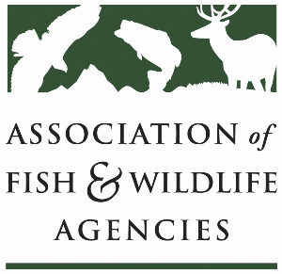

**Private LAnds Working Group**

**Chair: Will Newman, Texas**

**Vice-Chair: Ray Aberle, Colorado**

**Tuesday, March 11th, 2025**

**8:00 am – 10:00 am**

90th North American Wildlife and Natural Resources Conference

Louisville, Kentucky

**Agenda**

8:00 am Call to Order/Introductions/Review Agenda

8:15 am Presentation: Discussion about closing social science information and knowledge gaps by integrating social science into conservation delivery staff training and continuing education

* Ashley Gramza, Social Scientist, Playa Lakes Joint Venture

8:55 am Round table on partner agreements and Executive Order impacts

9:15 am New Business

* WLA meeting update
* Infographic for career roadmap
* Outreach and in-reach guides
* Training syllabus update
* Brainstorm term for “recreational landowner”

9:40 am Old Business

* NABCI Private Lands Guide
* Other updates and discussion for Capacity Development Effort

9:50 am Record Action Items, Form Task Groups, Set Product Goals

10:00 pm Adjourn