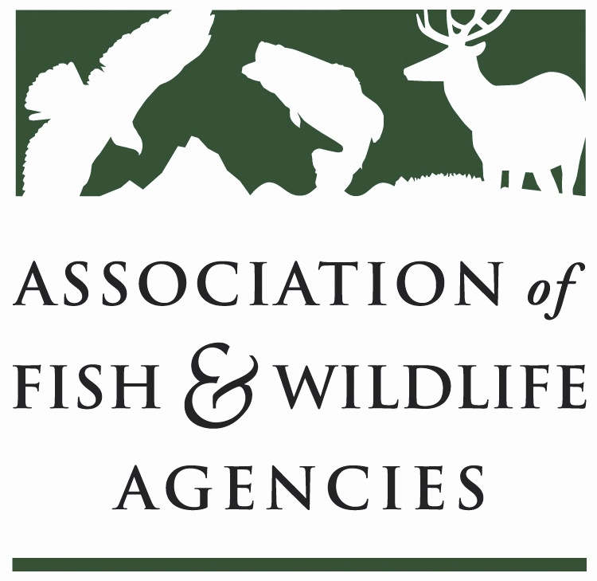

HARVEST INFORMATION PROGRAM WORKING GROUP
Chair: Karen Waldrop, Ducks Unlimited
Vice-Chair: Josh Avey, Arizona Game and Fish Department

Monday, September 19, 2022
4:00-5:00 p.m. PT

112th Association of Fish and Wildlife Agencies Annual Meeting

Agenda

4: 00 p.m. Call to Order/Review Agenda

4:05 p.m. Welcome and Introductions

4: 10 p.m. Approval of Minutes for the North American Meeting, March

4:15 p.m. Report from Kathy Fleming, USFWS
- HIP Stratification Analysis

4:30 p.m. Report from Brad Bortner, WMI and Phil Seng, DJCase and Associates
- Multi-state Grant Proposal Update

4:45 p.m. Roundtable Discussion

4:55 p.m. Moving Forward and Next Steps

Next Meeting/Conference Call

5:00 p.m. Adjourn

