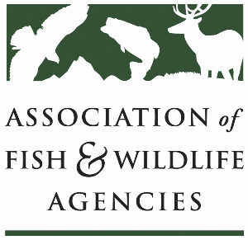

**AGRICULTURE CONSERVATION COMMITTEE**

**Chair: Kevin Robling (South Dakota)**

**Vice-Chair: Tim McCoy (Nebraska)**

**Thursday, March 13th, 2025**

**1:15 – 3:15 pm**

90th North American Wildlife and Natural Resources Conference

Louisville, Kentucky

**Agenda**

1:15 pm Call to order, Review agenda

1:20 pm Introductions

1:25 pm Approval of Minutes for the 2024 AFWA Conference

1:30 pm NRCS/FSA Updates

1:45 pm 2025 Farm Bill Priorities

2:15 pm Working Group Reports

* + - CRP
    - Easements
    - EQIP/CSP
    - Forestry
    - RCPP
    - Public Access
    - Private Lands

3:10 pm Final Remarks, Identification of Action Items

3:15 pm Adjourn